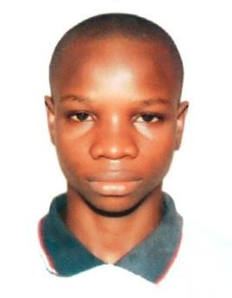
Ajibola

Ajibola.364557@2freemail.com

OBJECTIVE

Seeking an internship/work experience with a company where I can use my talents and skills to grow and expand the company.

EDUCATION
EMDI Institute, Dubai, UAE

Diploma in Events and Innovative Marketing Oct 2016 - Aug2017 Key Courses: Branding and Brand Management, Planning and Logistics, Experiential Marketing.

UniversityofLagos, Lagos, Nigeria

B. A. Creative Arts Oct 2010 - Feb2015 Key Courses: Advanced Technical Design, Writing Skill, Stage Management, Theatre Design & Technology.

Certified Soft Skills Professional
Dallas, TX USA Sep 2015 Key Topic: Time Management, Conflict Resolution, Problem Solving, Crisis Management.

WORK EXPERIENCE

Receptionist/ Social Media Assistant Aug 2016 – Mar 2017 How Can We Help? FZE

Proof read content, including but not limited to social media post, blog articles and press releases Help to increase conversion rates and ROI with regard to the above digital marketing channels

Administration of press taps

Producing and engaging social media campaigns from content creation to campaign success

Client Relations Officer Jan 2014 – Mar 2016
De- cathedral & Associates

Organization of Client Real Estate Information. Effective Client Liaison.

Maintaining the communication loop within the organization by assisting in the drafting of memo.

Intern and Broadcast Assistant
University of Lagos Radio Station 103.1FM Oct 2013- Dec 2013

Generating and researching ideas for new radio programs. Script writing.

Presenting programs and managing presenters for both pre-recorded and recorded output.

Sourcing potential contributors and Interviewees for the different radio programs on Unilag FM.

Volunteer/ Event Experience

Volunteer, Guns n Roses (Live) Dubai UAE, March 2017. Red Fest Dubai, Feb 2017.

18th global women in leadership economic forum, Dubai, Naseba events, Oct 2016. Sonu Nigam (Live in concert) , Dubai, Nov 2016

Dubai Jazz Festival, Feb 2017

The Dubai city swim, Promoseven sports marketing, Oct 2016 Fitness Middle east convention, Dubai, Nov 2016

SKILLS

Strong presentation skills.

Brand awareness and management.

Highly proficient in Microsoft Applications. Public and Media Relation.

Effective communication skills.

