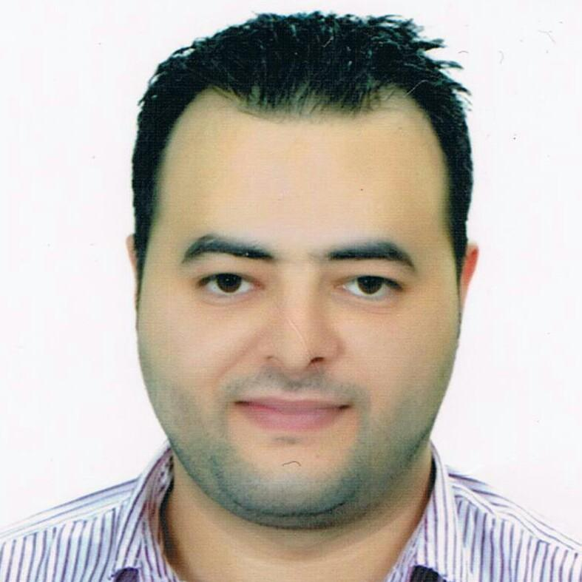
Ziad
Ziad.365176@2freemail.com

Personal Skills
- Strong analytical skill and able to makes links among several parts of issues or situations.
- Ability to tackle and analyse issues or situations in a logical and systematic manner.
- Ability to interpret information, situations or issues at hand.
- Detail oriented and able to analyse information from disparate sources.
- Strong presentation, communication and writing skills in Arabic and English.
- Fluency in English language.
- Excellent report-writing skills.
- An effective team player who is able to work both in a team environment as well as independently.
- Intellectually curious - eager to learn and acquire new skills.

Professional Skills
- Sufficient work experience at Service Desk, help users to solve specific work-related tasks
- Good interpersonal and relationship-building skills and a team player with high energy levels to work with cross-functional teams.
- Pro-active and inquisitive mind set to develop problem solving, decision making, conflict resolution and strategic thinking skills.
- Very Good written and verbal communication skills.
- Hardware and software maintenance.
- Experience in programming [Java ,C# , C++].
- Experience in IDE for systems [Eclipse , SAP system , Oracle DB system].
- Experience in web development [Yii framework , Symfony framework , Drupal framework].
- Development apps (Android , IOS)[Android studio , swift].
Career History
March 16th 2017 - Present
IT Manager, BrandToaster Digital Marketing Agency - UAE - Dubai Technology Entrepreneur Centre

Location: Dubai, UAE
Company Industry: Marketing Sector
Job Role: IT Manager.

- Supporting the roll-out of new applications.
- Monitoring and maintaining computer systems and networks.
- Diagnosing and solving hardware or software faults.
- Troubleshooting system and network problems.
- Testing and evaluating new technology.
October 2014 - November 2016
System Administrator, Syrian Ministry of Finance - Lattakia Finance Directorate

Location: Latakia, Syria
Company Industry: Government Sector
Job Role: Administration

- Perform daily backup operations, ensuring all required file systems and system data are successfully backed up to the appropriate media, recovery tapes or disks are created, and media is recycled and sent off site as necessary.
- Provide Systems Administration, including maintaining user/group accounts, user configuration, trouble-shooting access problems and completion of on-site documentation.
- Director of client server system in the Directorate of Finance of Lattakia.
- Assist in (IBM) Server, infrastructure management, performance monitoring, (UNIX) Operating System upgrades and troubleshooting.
- Perform daily system monitoring, verifying the integrity and availability of all hardware, server resources, systems and key processes, reviewing system logs, and verifying completion of scheduled jobs such as backups.
- Assist in support and security of network, Active Directory maintenance, Server Infrastructure maintenance, Network Infrastructure maintenance - wired & wireless .
- Network protection and failover tools, implementation (Firewall, web security, multi-homing devices, etc).Implement technology “best practices”.
- Ensure critical systems, specifically Front Office Property Management System.
- Monitor the work of customers, and their access to the network.
- Maintenance of the network, and complete the work at a specific time in the event of any sudden collapse.
- Provide system support services, including service outage diagnosis, troubleshooting and restoration of service, virus protection management
- Carry out regular maintenance, of the servers.
- Maintenance of computers and printers, in a network system.
- Evaluate and buy all the pieces and accessories necessary for the work of the servers and computers in the company's books and under the conditions laid down specifications.

September 2012 - February 2014
Head of systems Assistant Syrian Ministry of Finance - Lattakia Finance Directorate

Location: Latakia, Syria
Company Industry: Government Sector
Job Role: Administration Assistant

Operations and Support:

- Perform daily system monitoring, verifying the integrity and availability of all hardware, server resources, systems and key processes, reviewing system and application logs.
- Perform regular security monitoring to identify any possible intrusions
- Maintain, verify and optimize backup scheme, monitor free space on network storages.
- Monitor the work of customers and their access to the network.
- Perform regular file archival and purge as necessary.
- Repair and recover from hardware or software failures. Coordinate and communicate with impacted constituencies.

Maintenance:

- Prepare and Maintain operational, configuration, or other procedures.
- Perform periodic performance reporting to support capacity planning.
- Perform ongoing performance tuning, hardware upgrades, and resource optimization as required.

September 2008 - August 2012
technical support engineer Syrian Ministry of Finance - Lattakia Finance Directorate

Location: Latakia, Syria
Company Industry: Government Sector
Job Role: Maintenance, Repair, and Technician

- Preparation, installation and configuration of Desktop Devices in affiliate office locations.
- Installation or re-installation and support of software’s and server applications on Desktop Devices including operating system, patch updates, standard packages, device drivers etc. approved and provided by Finance Directorate.
- Periodic preventive maintenance as per the agreed schedule.
- Installation or re-installation and support of software’s and Finance applications on (server - client) including operating system, patch updates, standard packages, device drivers etc. approved and provided.
- Employment Insurance for personal computers in Directorate.
- Regular maintenance of all personal computers.
- Strict solutions to critical situations and at a specific time "solutions against time."
Education
2007 | Bachelor's Degree, Tishreen University , Lattakia, Syria
Informatics Engineering Department of software engineering and information System

2007graduation Project|
- The completed project in the year of graduation (smart client application) using .NET platform and programming language C#. The idea of ​​the project is the representative of global sales. The program offers sales service and inquire about any material in the warehouse around the globe and has all the potential scenarios address.

2006 Project|
- Draft submitted to cover Web technologies (Web Development) using the language (Php) and (html - css - Js) and supported by a database (MySQL). The project offers a model for the query and the search for the types of computers and used the pieces in this area and the possibility of comparison between the types and prices of potential in the market .
Languages
- Arabic mother tongue
- Fluency in English.

