CURRICULAM VITAE
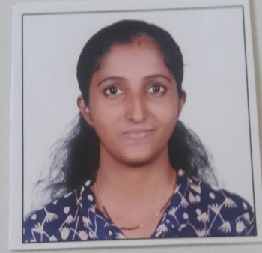
DEEPIKA
DEEPIKA.366514@2freemail.com

Objective:
To seek experience in a dynamic environment where my knowledge can be enriched. Looking forward an opportunity where I can develop my communication skills and implementing to my skills.
Academic Qualification:
S.Y.Bcom
2003-2004: Higher Secondary Certificate, Maharashtra
2000-2001: Secondary School Certificate, Maharashtra.

Additional Qualifications:
Computer Skills:
- Basic Computer Applications (Microsoft Office)
- Html, Dhtml, FrontPage, Flash.

Communication Skills:
- Able to read, write and speak fluent English, Hindi and Marathi.
Strengths:
- Competitive analytical skills.
- Excellent communication and interpersonal skills.
- Fast learner and ability to function as a team player and alternatively work independently to achieve objectives.

Work Experience:
Wellspring Healthcare Pvt Ltd, Mumbai (4th April 2016 – 31st March 2017)
- Working as Senior Customer Service Executive
Tata Business Support Services Ltd., Mumbai (27th Dec 2014 – 1st Feb 2016)
- Working as Customer Service Associate in Pre-sales for Vijay Group
United Technology & Trading Co., Dubai (Sept 2011 – April 2012)
- Working as Office Assisstant
- Handling Calls, Billing
- Preparing Quotations
Cybersites India Technologies Pvt Ltd, Mumbai (15th Jan 2007 – 1st Dec 2014)
- Working as Senior Marketing Executive
- Attending customer queries and providing assistance accordingly via email and calls.
- Assigning jobs to colleagues
- Checking payments & payment related issues
- Handling billing
Hobbies And Interests:
- Making friends
- Reading books
- Listening music
- And travelling extensively.

Dated: 29th January 2017

