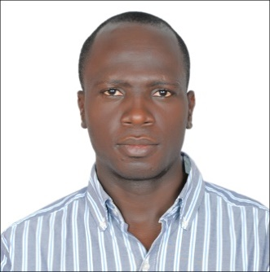
MICHAEL
MICHAEL.366687@2freemail.com
CAREER OBJECTIVE
To strive for excellence and precision at all time in all positions and circumstance ,attaining professional distinction and proficiency to seek a career in a reputable establishment in which professional skill are fully, harnessed and there is ample room for personal growth and development. To develop a career with a reputable organization whose priorities are placed in the achievement of excellence through hard work, result oriented services, integrity and invade desire to succeed.
WORK EXPERIENCE :-
COMPANY: ABU DHABI NATIONAL HOTELS COMPASS ME L.L.C
ADDRESS: P.O.BOX 109767 ABU DHABI UNITED ARAB EMIRATES
POSITION: ADMINISTRATIVE / ACCOMMADATION CLERK
INCLUSIVE DATE: MAY 27TH 2012 TILL DATE
Company: ABITECH ENGINEERING LTD.
Address: IKEJA LAGOS NIGERIA
Position: PROJECT & STRUCTURAL CABLING SUPERVISOR
Date: 2008
Company: INTRA METROPOLITAN TECHNOLOGY
Address IKEJA LAGOS NIGERIA
Position: SALES EXECUTIVE /SYS. ENG.INSTRUCTOR
Date: 2003
Company: SOVEREIGN SHIP MANAGEMENT LTD/UNOIN MARINE
POSITION ORDINARY SEAMAN (O/S)
Date: 2011
ADDRESS: A-305 DYNESTY BUSINESS PARK.ANDHERI

INSTITUTIONS ATTENDED WITH DATE
- EKITI PARAPO COLLEGE, EKITI STATE. 1995
- UNIVERSITY OF AGRICULTURE 2002
- INTRA METROPOLITAN TECHNOLOGY IKEJA,LAGOS 2002
- EMIRATES TECHNICAL &SAFETY DEVELOPMENT CENTER 2013
- CHARKIN MARITIME &OFFSHORE SAFETY CENTER 2015
QULIFICATIONS OBTAINED WIYH DATE
- SENIOR SECODARY SCHOOL CERTIFICATE 1995
- DIPLOMA CERTIFICATE IN COMPUTER ENGINEERING AND NETWORKING 2003
- FIRE WARDENS 2013
- OSHAcademy, USA (Online): Prof Cert (Essentials of Occupational Safe &Health )
- OSHAcademy, USA (Online): Introduction to occupational Safety &Health
- STCW BASIC SAFETY TRAINING 2015
- PERSONAL SURVIVAL TECHNIQUES
- FIRE PREVENTION & FIRE FIGHTING
- ELEMENTRAY FIRST AID
- PERSONAL SAFETY &SOCIAL RESPONSIBILITY
- BASIC OIL AND CHEMICAL TANKER CARGO OPERATION
- ISPS AWARENESS

BIO- DATA
Date of Birth: 14th June, 1975
Place of Birth: Ekiti State
State Of Origin: Ekiti state
Local Govt Area: Efon Alaiye
Sex: Male
Nationality: Nigerian
Marital Status: Married
Language Spoken: English and Yoruba
HOBBIES
Solving problems, traveling, Foot balling

