**SHARHEA**

[*Sharhea.368590@2freemail.com*](mailto:Sharhea.368590@2freemail.com)

**Career Overview**

I am enthusiastic and creative Graphic Designer with over 8 years experience in Retail industry. My strengths are in design and free hand drawing. I am passionate on my work and I enjoy meeting new challenges and utilizing my time-management and organizational skills to ensure that my work is completed to strict timelines with accuracy and attention to details. I am committed to working to an exceptionally high standard in everything I do.

**Skills Summary**

Manual Free Hand Drawing, Illustrations, Accessories embellishments, Basic Photography

Graphic Design Profecient in Adobe Illustration CC, Adobe Photoshop CC, CorelDraw12,

Specialties Branding and Identity, Product development, Apparel development, Graphic

Illustrator and Trend direction ( Theme, Colors, Prints, Fashion statement ).

**Professional Experience**

**Sana Fashion LLC.**

Dubai, United Arab Emirates 2/2016-Present



***Senior Design Coordinator/Designer***

* Research and develop design trend collection for Infants, Kids, Men’s and Ladies per season.
* Develops technical sheets and drawings which detail various design elements, i.e. color scheme, construction and material type.
* Work with the Directors, Buyers and merchandisers to plan for the season.
* Engages with suppliers to examine and ensure quality of materials and design elements are properly executed.
* Product Branding such as Logos, Packaging, Hangtags, trims and labels.
* Conducts market research.

**Arabic Triangle Trading LLC.** 3/2015- 1/2016

Dubai, United Arab Emirates

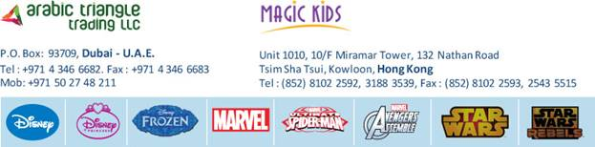

***Graphic Designer***

* Creating designs thru style guides of Walt Disney, Marvel, Star Wars etc,
* Designing garments, footwears and accessories for infants and kids.
* Recommending new fashion ideas and tips that facilitates the better look and images of the brand.

**BMA International FZE** 3/2014-3/2015

Dubai, United Arab Emirates

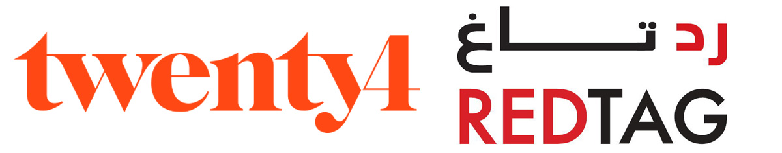

***Graphic Designer***

* Worked with Buyers, and creating Graphic Designs (fashion collection,style silhouettes, labels) for Garments.
* Assist with research and selection of fabrics, components and trims for seasonal introductions of new colors and styles
* Responsible for producing work details on technical packs.
* Be committed to timelines and work over and above the allotted work hours if deadlines require.

**Eurowear Marketing. Corp.** 7/2007-12/2013

*Manila, Philippines*

***Visual Merchandiser/Senior Designer***

* Lead the designs, development and set up of the visual display of a store.
* Researching upcoming trends.
* Creating print, Fashion designs, embellishments and graphic layouts.
* Helps the team for the development of product line, from concepts to production.

**Education**

**Far Eastern University** *Manila, Philippines* 1997-2003

**Bachelor in Fine Arts** (Major in Advertising)

**Personal Information**

Status                     Single

Citizenship            Filipino

Visa Status Employment (Transferrable)