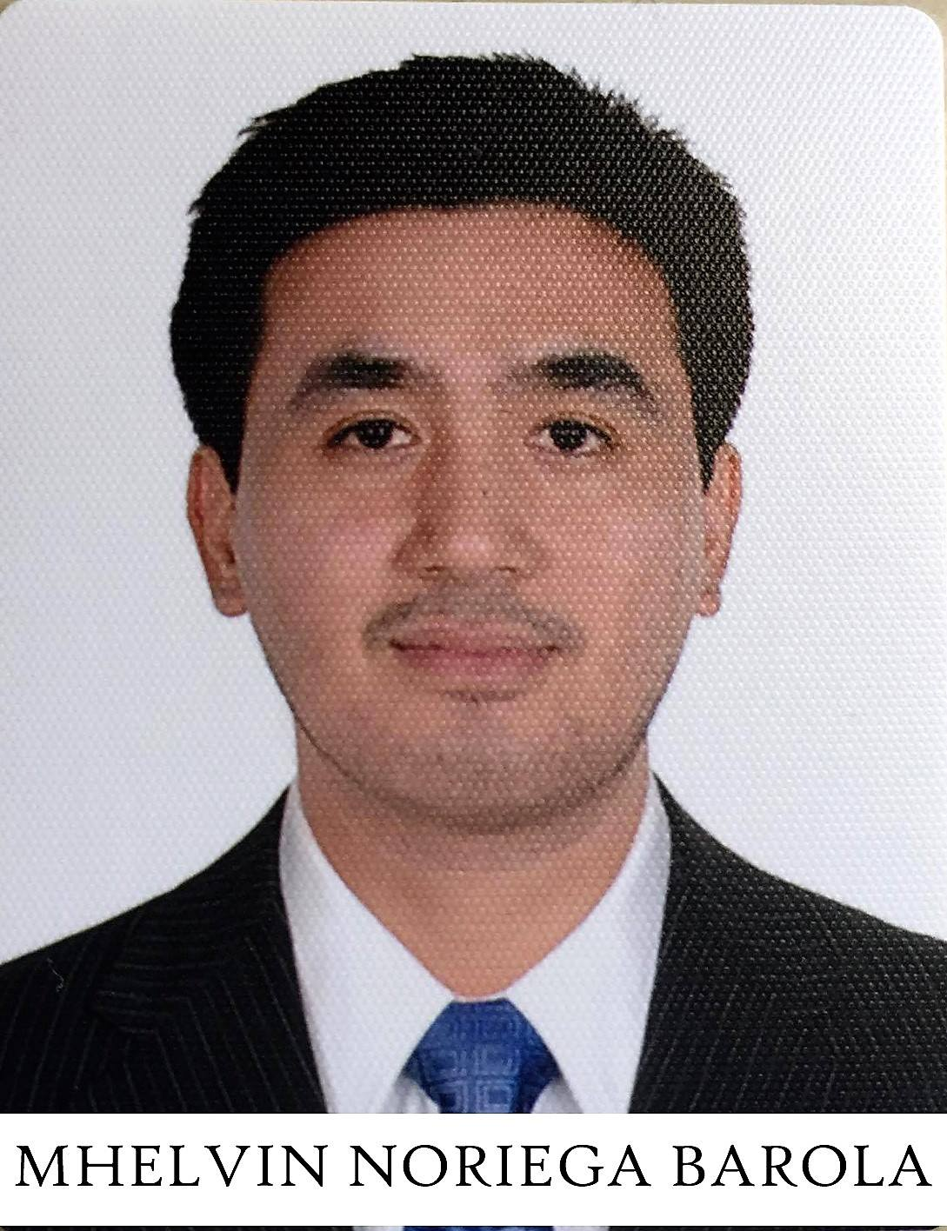
MHELVIN
Email: mhelvin.368832@2freemail.com

CAREER OBJECTIVE

To be able to utilize my skills and work experiences. Enhance my knowledge in my chosen field of work and to work with quality and safety at hand.

WORK EXPERIENCE

HAAD PASSER-February 19, 2017

Tawi Attair Hospital (Ministry of Health - Oman)
(March 2016 – December 18, 2016)

Mirbat Hospital (Ministry of Health Oman)
Oman - Dhofar Region
(September 15, 2013 – March 2016)

Staff Nurse (Medical Surgical Ward)
Las Pinas Doctors Hospital
8009 J.I. Aguilar Avenue. Pulang Lupa II Las Pinas City, Philippines
(October 2007 – August 2013)

TRAININGS AND SEMINARS

Healthcare Professional - Basic Life Support
December 18, 2016

Disaster Plan in PHC (Triaging and Ambulance care) Workshop
Mirbat Hospital (Ministry of Health)
December 2015

ECG Workshop
Hilton Salalah Hotel (Ministry of Health)
August 2015

Trauma Life Support Workshop
Sultan Qaboos Hospital (Ministry of Health)
March 2015
Basic Life Support Provider
Mirbat Hospital (Ministry of Health)
June 2014

EDUCATIONAL BACKGROUND

COLLEGE 2003-2007 Bachelor of Science in Nursing
Lyceum of Batangas
(now Lyceum of the Philippines University
– Batangas)

SECONDARY 1999-2003 University of Batangas
Hilltop Batangas City

ELEMENTARY 1993-1999 Banaba East Elementary School
Banaba East, Batangas City

IELTS:
Listening - 7.5
Reading -7.5
Writing - 6.5
Speaking - 7.0
Overall - 7.0

PERSONAL DATA
Date of Birth : May 22, 1987
Citizenship : Filipino
Religion : Roman Catholic
Height : 5’9”
Weight : 150 lbs.
Civil Status : Single
Language Spoken : English and Filipino

I hereby certify that the above information is true and correct.

MHELVIN

