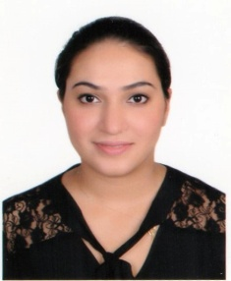
Amna
Date of Birth: 26/08/1989
Email: amna.368907@2freemail.com
Nationality: Pakistani
Marital Status: Married (Husband’s sponsorship)
Objective:
To begin my teaching career at a well-liked and well-reputed nursery and to achieve good progress in my career through my best subject knowledge and great teaching efforts
Key Skills:
- Excellent communication skills, good knowledge of Montessori principles, and methods of teaching
- Positive, sensitive and respectful attitude to the children, ability to ascertain the needs of children
- Ability to provide safe and stimulating environment that facilitate learning
- Ability to prepare lesson plans and implement age appropriate activities
- Organising and supervising play and work activities for example reading, music, dancing etc)
- Ability to work as a team by helping, planning, sharing knowledge and coordinating work indoors and outdoors
- Good classroom management, Patience, Responsible & Creativity
- Maintaining records
- Monitoring and recording progress

Academic Education:
- Montessori Centre International
International diploma in Montessori Pedagogy, Early Childhood Course, 2017
- Montessori Centre International
Stage 2:
Montessori Theory and Methodology, Early Childhood Course, 2015
- Paediatric First Aid: June 2015
- Bachelor of Arts, Pakistan
Computer Literate:
In MS Word, Access Database, Power Point, MS Excel and Email
Work experience:
September 2016- February 2017
Gulf Montessori Nursery (Montessori teacher)
September 2013- March 2014
The Primary Nursery, Dubai (Nursery Teacher)
Applying and enforcing ground rules included moral lessons such as sharing, taking care of other children’s feeling & emotions, team work, maintaining basic etiquettes and hygiene
Conducting individual and group activities
Encouraging learning through fun activities and role playing
Preparing and executing lesson plans
Ensuring the highest level of care and security for children
To prepare children for the next phase of learning
Personal skills:
As preschool teacher I took the responsibility of teaching theoretical, practical sessions of lessons taught, coordinating games and fun activities among children. I was responsible for not only making lesson plans but also for managing the class allotted to me. I planned and organized individual and group activities in play, dance, outdoor activities and arts and crafts to bring out children’s talent and to help them to improve their skills.

