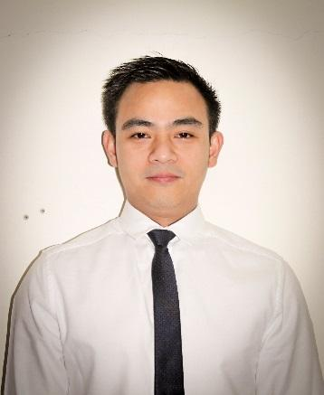

JOSEFINO
JOSEFINO.368921@2freemail.com

“Being in the Hospitality Industry have brought lots of learning for me. Be it personal or professional aspect, it really has helped me improve a lot specially in building the right rapport between people. I know that this learnings that I’ve got will definitely be an asset I can use to keep improving and will bring me great results towards my work and my own personal aspirations”

SKILLS/ ABILITY

• Great customer service skills
• Excellent communication skills
• Flexible in different work related tasks
• Easy to understand company policy and work standards and a fast learner
• Adaptable and multitasking within busy and under pressure environment
• Can perform various work such as office admin, stock clerk, waiter, room attendant, and other customer service related jobs.

PERSONAL DATA

Date of Birth: September 13, 1984 Age: 32
Place of Birth: Philippines Height: 5'6"
Citizenship: Filipino Gender: Male
Religion: Roman Catholic Status: Single

WORK EXPERIENCE

November 2014- May 2017 ROOM ATTENDANT
Crowne Plaza Abu Dhabi Hotel (5*)
Hamdan Bin Mohammed Street, Abu Dhabi, UAE

August 2010 - September 2011 STOCK CLERK
International Toy World Inc.| Philippines

July 2009 - June 2010 SALES EXECUTIVE
Metro Shopper Uniwide Philippines

April 2007 - June 2009 SALES REPRESENTATIVE
J’Mart Department Store
Philippines

August 2005 – March 2007 WAITER
Butterworld Restaurant
Philippines

