RAGHU
International & Domestic Logistics & Transportation ~ Strategic Planning
An effective leader with 24 years expertise in setting-up objectives, designing & streamlining business processes and executing work to improve productivity & reduce cost, targeting assignments in Courier/Air Express, E Commerce, Transportation, Fleet Management Industry

Raghu.368952@2freemail.com
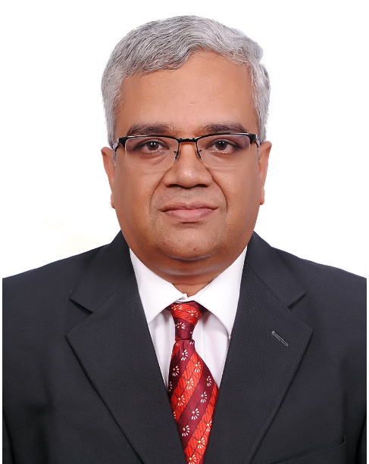
Profile Summary
- Talented and versatile management professional with cross-functional experience , specialized skills in Transportation Management, Logistics Operations, Packing and dispatch activities, Project Management, Cross functional coordination, Safety and Team Management.
- Taking complete ownership of the cycle count process including the analysis and follow up actions that will ensure continued improvement of material accuracy.
- Track record of establishing processes & SOPs, streamlining workflow and creating work environment to optimize resource & capacity utilization and escalate productivity & operational efficiencies
- Proficient in sustaining healthy relations with variety of stakeholders including customers, suppliers and logistics partners for planning, coordinating and monitoring the receipt, order assembly and dispatch of cargo/goods
- Multitasking credentials with excellent planning, execution, monitoring, resource-balancing and problem solving skills, as well as the ability to handle multiple projects/tasks in high pressure environments.
- Possess invaluable experience in interfacing and working with multicultural people, languages and varied culture & customs
Core Competencies  Courier /Air Express Operations  Global Logistics & Transportation  Supply Chain Management  Fleet Management  Stock Management / SLA Management and Budget Control  Customer Relationship Management  Process Improvement  Operations Management  Team Building & Leadership |  | Academic Details  - B.Com. from Sri Sathya Sai Institute of Higher Learning, Bangalore University in 1987  Notable Accomplishments Across the Career  Fits Aviation (Pvt.) Ltd., Afghanistan  - Managed USD 10 million in international logistics and transportation  - Supervised global operations and process improvement initiatives with a team of 40 direct and over 80 indirect employees.  - Provided the capability to accurately allocate transportation costs and quote transportation costs proactively which resulted in increased revenues.  - Designed ground-breaking logistical solutions for global supply chains which greatly enhanced the performance  - Played a pivotal role in formulating policies and procedures for the smooth take over from the previous agency  - Provided training to the new employees in all aspects of Operations, Scanner Usage, Customer Service and Front Office Management  - Prepared daily, weekly and monthly reports needed to be sent to the head office to ensure all the operational and Finance compliance were met.  - Liaised with Head Office for Audit and Finance and ensured all the billings were done in a timely manner  Afghan Express Ltd., Kabul, Afghanistan  - Initiated FedEx Operations in Bagram, Kandahar, Jalalabad, Marmal, Kabul, Camp Phoenix, Camp Bastian, FOB Sharana and FOB Shank  - Started direct flight operations from Dubai regional hub to the Military bases in Afghanistan  - Coordinated for the employment of new employees needed and trained them based on the needs of the specific locations.  - Coordinated with customs officials in the Ministry of Finance for formulating customs procedures for courier companies in Afghanistan  - Began trucking services between all the bases in Afghanistan and managed the movement of around 150 trucks a month between various locations which helped in generating a revenue od USD 2.5 million  Oman Postal Express, Muscat  - Bagged ‘Best of the Best Award’ in Dec’92 for delivering outstanding support within MEIA region
Skill Set

Change Agent
Motivator
Communicator
Collaborator
Career Timeline  Feb’92 – Jul’93  Hevea Engineers Private Limited, Chennai  Jan’94 – Jul’04  Oman Postal Express, Muscat  Jan’05 – Feb’14  Afghan Express Ltd., Kabul, Afghanistan  Mar’14 – Jan’17  Fits Aviation (Pvt.) Ltd., Afghanistan  Kalium, Dubai as Logistics & Supply Chain Consultant  Kalium, Dubai as Logistics & Supply Chain Consultant  Kalium, Dubai as Logistics & Supply Chain Consultant | Organizational Experience  Fits Aviation (Pvt.) Ltd., Afghanistan from Mar’14 – Jan’17 as GSP Service Manager  Key Result Areas:  - Ensuring that all the stations in Afghanistan maintained the service levels as determined by FedEx.  - Responsible for handling the complete trucking arrangements within Afghanistan  - Providing outstanding logistic supports, consistency, continuation, material administration also handling other responsibilities based on the logistic programs  - Assigning the tasks of processing shipments of materials and equipment like confirming of delivery as well as liaise with shipping vendors and customers.  - Managing timely and smooth dispatch of different services in accordance with the plan. Liaising with the transporters for ensuring timely dispatch of the materials.  - Developing dispatch report on daily basis for tracking the status of the dispatched products. Ensuring service levels of all the locations in Afghanistan and timely planning & coordination for the trucks between various locations in Afghanistan.  - Monitoring transportation scheduling and controlling operations, interfacing with customers and supplies for negotiations and analyzing data to monitor performance and plan improvements  - Planning & implementing staff training and interacting with the customer to ensure complete satisfaction. Acting as Single Point Contact for entire FedEx Team in Dubai Regional Headquarters  - Defining guidelines, SOPs, Templates and Manuals for multi-disciplines marketing, operations, administration & security  - Leading high-level implementation plans and determining future logistics organizational structure/support ensuring Delivery-in-Full (DIF) and Delivery-on-Time (DOT)  - Reviewing company’s logistics operations business practices, updating & developing process documentation, streamlining opportunities and eliminating non-value added activities  Afghan Express Ltd., Kabul, Afghanistan, Licensee of Federal Express Corporation from Jan’05 – Feb’14 as Base Operations Manager  Oman Postal Express, Muscat from Jan’94 – Jul’04 as Operations Manager  Growth Path:  Jan’94 – Mar’94: Accountant  Apr’94 – Nov’ 94: Chief Accountant  Dec’95 - Jul'04: Operations Manager  Hevea Engineers Private Limited, Chennai from Feb’92 – Jul’93 as Accountant
Personal Details
Date of Birth: 28th July 1966
Languages Known: English, Hindi, Tamil and Kannada

