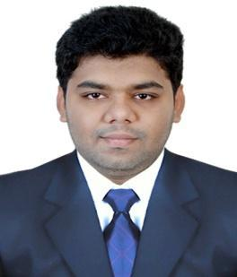
CURRICULAM VITAE

Name : Mohammed
E-mail: mohammed.368991@2freemail.com
Visa :visit visa

PROFILE:

I have Over 2years of Selling Experience in the field of Electronics Industry. Young dynamic self-motivated confident. I do the job with great sense of responsibility and always expect to make a positive contribution and prove my self is an asset to the organization, which employs me.

PROFESSIONAL EXPERIENCE:

BAJAJ ELECTRONICS
Malakpet,Hyderabad. India
Worked as a Sales Executive
From : 20th Aug 2014 to 2ndSep 2016

- Maintaining stocks and daily sales tracker.
- Attending customers and fulfilling their needs and requirements.
- Maintaining good relationship with customers and providing assistance in selecting their products. Promoting new arrivals to the customers.
- Achieving the sales target laid by the company following company rules and regulations.
- Sales MerchandiserFor Samsung.

EDUCATION QUALIFICATION:

B.com Computers
From ManavBharti University (2013)

Intermediate 10+2
Utter Pradesh / India (2010)

SSC from Board of Secondary Education
Hyderbad / Telangana India(2008)

Skills

- Microsoft office.
- Tally 9.0 ERP-9, Peachtree.
- Drive for continuous improvement through hard work and being persistent.
- Urge to learn and explore new horizon.
- Ananalytical mind with the ability to think clearly and logically.
- Ability to work accurately and pay attention to details.
STRENGTHS:

- Good team player skills, ability to withstand pressure.
- Finely to work in different environment.
- Leadership and decision making capabilities.
- Well organized and proficient with details.
- Dedication to work and strive for goals in life.
- Organized and focused approach towards a particular task.

Languages known:

English( written and spoken fluently)
Hindi ( written and spoken fluently)

PERSONAL INFORMATION:
Date Of Birth : 7 April 1992
Gender : Male
Marital Status : Single
Religion : Islam
Nationality : Indian
Visa Status : Visit visa
Visa Expiry : 09 July 2017

I here by declare that all the above information is true and correct to the best of my knowledge and ability.

In the end I assure your sir, that if I selected by your firm you will be convinced of my efficiency and dedication of work.

PLACE: Dubai, United Arab Emirates
(Mohammed)

