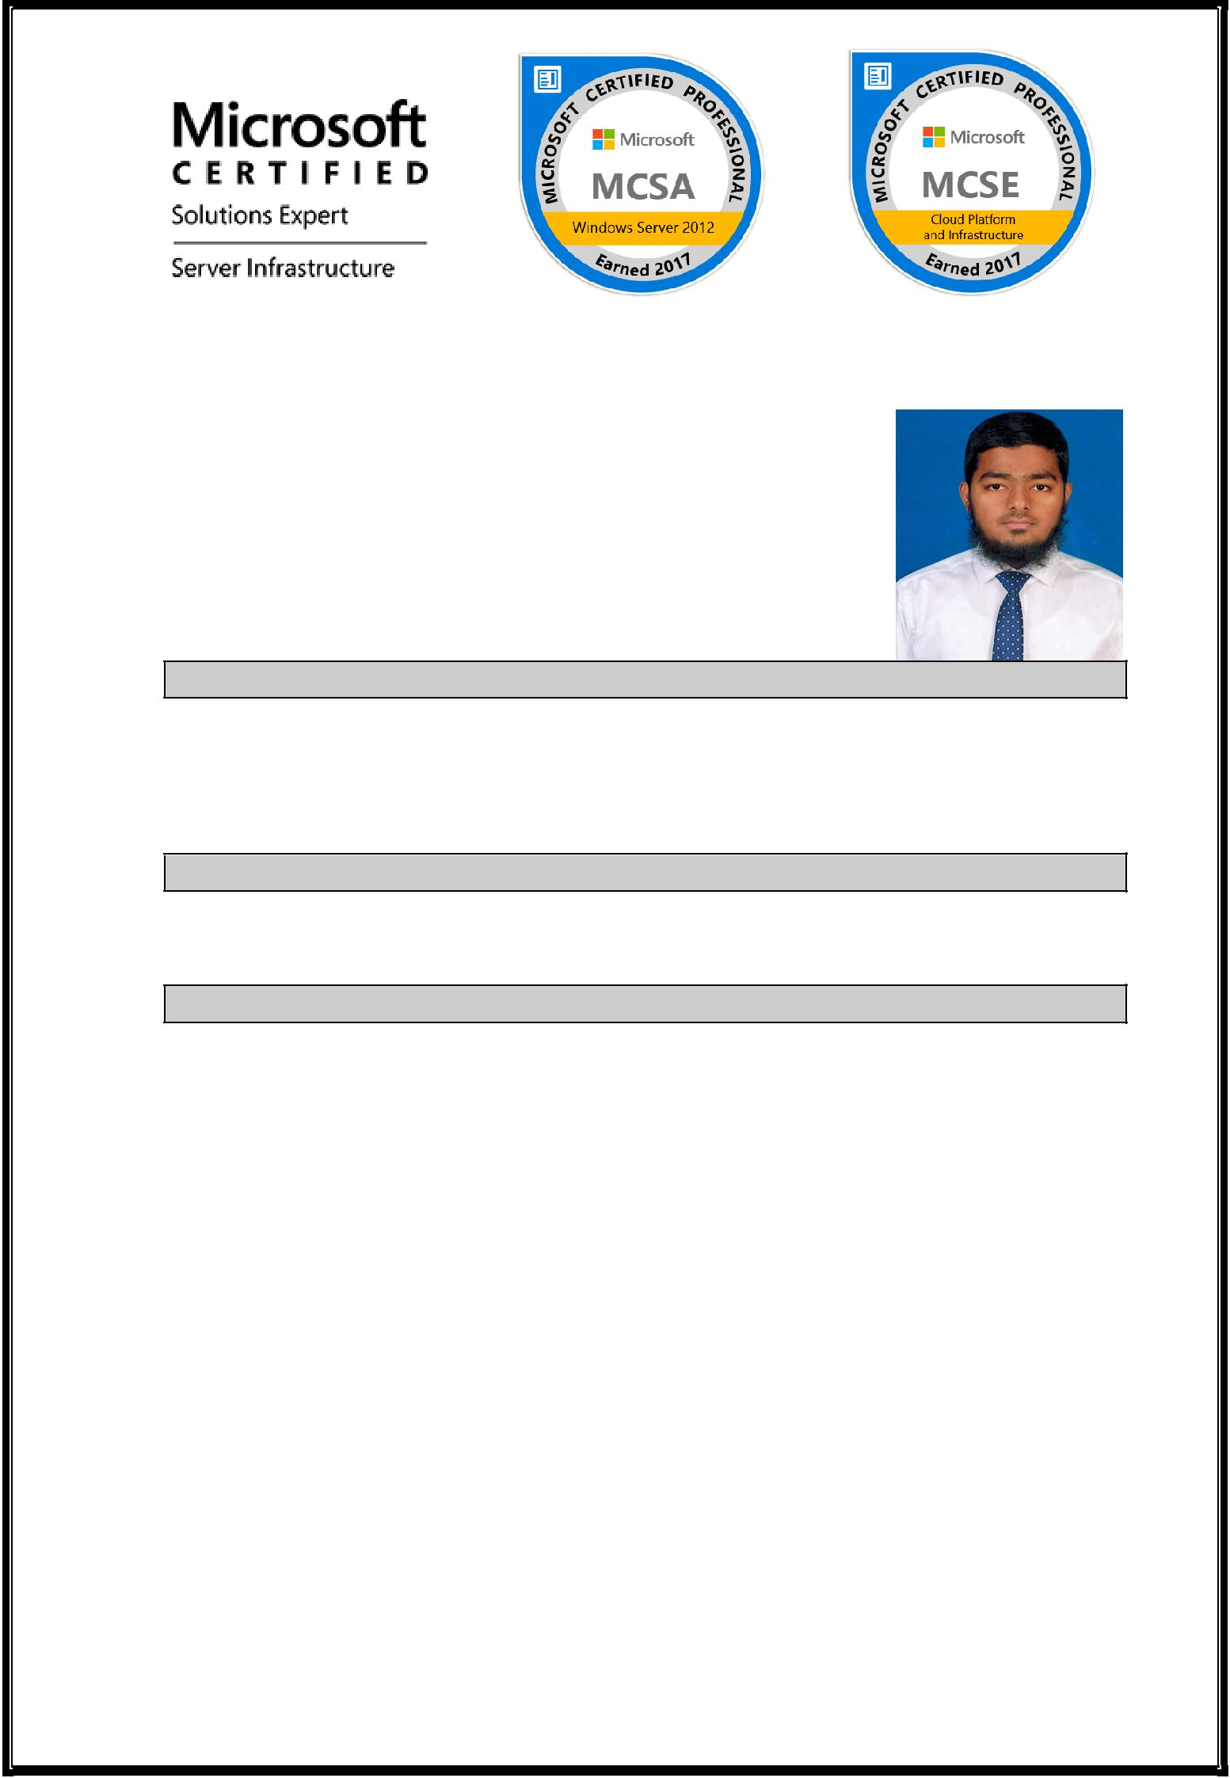

CURRICULUM VITAE

SALMAN
Email: salman.369022@2freemail.com

Career Objective:

To secure a challenging position in a reputed organization where I can effectively contribute my skills and utilize my professional qualification to provide growth prospects to the organization.

Working Experience:

Worked as a Jr. System Administrator with Sahitya Technology Pvt Ltd.

Job Description:

To support Windows server platform.

Maintain the Security Standards for Global service delivery.

Strictly follow the Service Level Agreement (SLA) process for giving effective support to the client.

Providing Remote support for the issues on Windows environment.

Supporting the Windows 2008/2012 Active Directory environment.

Installing, configuring and managing windows Server 2008 and windows 2012 server.

Managing Users, Computers & Groups. Creating & Managing the OUs.

Basic knowledge on various servers like DNS, DHCP, DFS and FTP etc.

Managing File & Print servers

Handling Customer problems on priority and Maintaining closing the calls. Maintaining & troubleshooting of users of Windows XP desktop PC, Laptops, Network Printers.

Managing Remote desktop Connection and Providing VPN connection

Providing day-to-day support for users reset password, Account lockout, Home directory, Outlook, Network Printers, intranet applications.

Educational Qualification:

B.Tech (Bachelor of Technology) in Computer Science Engineering, from Jawaharlal Nehru Technological University, Hyderabad.

Board of Intermediate Education - year 2012. SSC passed - year 2010.

Technical Certifications:

MCSE, MCSA from recognized Microsoft Certified Professional..

Technical Skills:

.

System Administration : Configuring and maintaining Active Directory, Group Policy Management on Windows 2012 Server Operating System.

Network Administration: DNS,DHCP and transferring roles of ADDS.

 | Operating System | : Windows Server Operating System 2012.
 | Security | : Implementing security\share level
 |  | permissions on drives, Folders & files.
 | Technical Expertise:

Installing & Configuring Active Directory-Domain Service in Windows server 2012.
Configuring Client or Configuring Member Server.

Configuring Home Folder & Configuring FSRM on Home Folder. Configuring & Implementing Trust Relationship.

Transferring & Seizing of FSMO roles

Delegation of control to one or more users in OU and implementing Group policies in it.

Configuring & Maintaining the Network Servers like DHCP, DNS, WDS. Configuring & Implementing Internet Information Service.

Strengths:

Good understanding ability

Driving initiatives within the team. A flair of learning new technology Good listening skills
Ability to handle the challenging tasks.

Academic Projects:

.
MINI PROJECT:

Title

: IT Service Helpdesk.

Abstract

: It deals with the problems faced by the clients at the time

of using respective software technology.

MAJOR PROJECT:

Discovery of Ranking Fraud for Mobile Apps.

Description : This project refers to fraudulent or deceptive activities

which have a purpose of bumping up the Apps in the rating list.

Advantages :

  - We can detect the time when fraud happens.

  - We have a scalable way to detect ranking fraud without using any benchmark information.

Personal Details:

 | Date of Birth | : | 29-07-1994.
 | Sex | : | Male
 | Marital Status | : | Single
 | Visa status | : | Visit Visa
 | Nationality | : | Indian
 | Language Known | : | English, Hindi,Telugu
 | Permanent Address | : | Hyderabad , India
 | Declaration:

I here by declared that information provided above is true and correct as per my knowledge and belief and I am solely responsible for its accuracy. If I get an opportunity to work in your organization, will put my best efforts.

 | Date | Yours Faithfully,
 | Place: DUBAI | (Salman)

