CURRICULUM VITAE
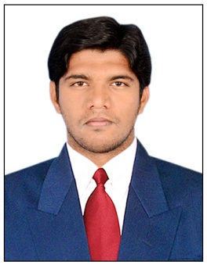
MOHMMED
MOHMMED.369119@2freemail.com

Career Objective:

To work in a firm with a professional work driven environment. Where I can utilize and apply my knowledge and skills which would enable me as an Experienced Accountant to grow while fulfilling organizational goals. Learning new techniques in the department and improve my performance

education:

Bachelor of Computers (B.com ) : Satavahana University, Karimnagar.
- Intermediate (C.E.C) : Board of Intermediate, Hyderabad.

WORK EXPERIENCE:

- Company : Quadri & Co. (2014 – 2017)
- Designation : Accountant

Responsibilites:
- Update accounts on tally and perform reconciliations
- Assist in the processing of balance sheets, income statements and other financial statements
- Assist with reviewing of expenses, payroll records etc. as assigned
- Prepare and submit weekly/monthly reports
- Assist senior accountants in the preparation of monthly/yearly closings.
- Responsible for handling the cash.

- Coordinating subordinates to ensure smooth accounting.

- Handling self correspondence with business clients.

- Diplomatic and excellent in public relation and office administration.

- Strong in interaction with auditors and finalization of accounts.

TECHNICAL SKILLS

- Accounting Packages : Tally-ERP9, Focus
(Sales tax, Vat, Payrolls)
- Other skills : Ms-Office, Typing Skills 30w.p.m. Computer Hardware
- Operating Systems : Window 7, xp1, xp2, xp3, Vista, 7 Premium,

Personality Traits:

- Communication Skills.
- Self Propelled and Creative.
- Excellent Analytical Abilities.
- Hardworking , reliable and honest.

DECLARATION:

- I here by declare that the above information furnished is true to the best of my knowledge.

