WILFRED
Email Add. : Wilfred.369127@2freemail.com

CAREER OBJECTIVES:
To work and grow in a professional environment where my knowledge, experience, and creativity can be put to the best use. I am looking for an opportunity to further develop and nourish my existing proficiencies and work experience.
WORK EXPERIENCE:

POSITION : Student Assistant
COMPANY : Pangasinan State University - Computer Laboratory
&Student Services & Alumni Affairs Office
DATE : November 2011- March 2015

POSITION : Customer Service Representatives
COMPANY : Uberdeli, Corporation
DATE : May 4, 2015 up to present

JOB DESCRIPTION:

Manage the order of products by the shop’s or franchisee.
Printing Delivery Receipt by Shop.
Encoding the orders and quantity of returned products.
Filing of returned Delivery Receipts and Throw Away Forms.
Issuingofficial receipts for the payment of the franchisee or shops.
Depositing of payment collection.
Making and sending reports to the Heads.
Monitor the outgoing products if it is complete and quality.

CERTIFICATE:

TESDA CERTIFICATE:
Computer Hardware Servicing NC II (CHS-NC II)
TESDA PSAT – Lingayen, Pangasinan, Philippines
November 11, 2014
EDUCATIONAL ATTAINTMENT:

TERTIARY : Pangasinan State University – San Carlos Campus
San Carlos City, Pangasinan, Philippines
COURSE : B.S. in Information and Communications Technology
Graduated
2011-2015

SECONDARY : Pangalangan National High School
San Carlos City, Pangasinan, Philippines
2007-2011

PRIMARY : Pangalangan Elementary School
San Carlos City, Pangasinan, Philippines
2001-2007

BACKGROUND INFORMATION:
Birth Date : June 14, 1995
Age : 21 years old
Gender : Male
Civil Status : Single
Citizenship : Filipino
Height : 5’7”
Weight : 65 kg
Religion : Roman Catholic

I hereby certify that the above information is true and correct to the best of my knowledge and belief.
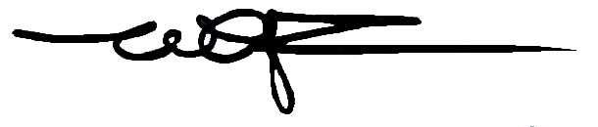
WILFRED
Applicant

