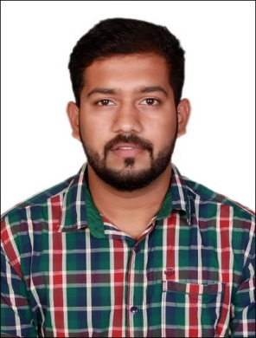
BENDICT
Email: benedict.369159@2freemail.com

CAREER OBJECTIVE

To grab opportunities that comes in my way and by implementing my skills and knowledge that I have learnt, to prove myself as the asset for the organization where ever I work.

EDUCATIONAL QUALIFICATIONS
Subject | Board/University | College/Institution | Year of Passing | Percentage
B.COM | Mangalore University | ST. Philomena College , Puttur | 2015 | 62%
12th/PUC | Department Of Pre-University Education | ST. Philomena College Puttur | 2012 | 55.33%
SSLC | Karnataka Secondary Education Examination Board | ST. Philomena High School Puttur | 2010 | 53.92%

KEY SKILLS
- Good Communicator
- Creative
- Decision Making Ability
- Good Motivator
- Good Listener
- Good problem solving skills
- Ability to work in a group
- Hard working and disciplined

WORK EXPERIENCE

Company: Prime Focus Technologies
Designation: Media Associate (Data Entry,Operational support)
Project: Hotstar
Duration: August 2015 to November 2016
Skills: XML Editing, CMS Operating, Data Entry.

RESPONSIBILITIES HANDLED

- Preparing the plan according to the client needs.
- Rectifying the errors.
- Ensuring that work should be done on time.
- Review and check applications and supporting documents.
- Audit online applications for accuracy and completeness.
- Supervising the each stage of processing of files till it’s completed.
- Manage application changes.
- Maintain complete activity logs and prepare reports.

Company: Souza Company.
Designation: Sales Person
RESPONSIBILITIES HANDLED:
Preparing Invoice, handling cashier duties, interacting and providing knowledge about the new products in the market, creating new customers, getting orders of the products from customers, Ensure that the products are well stocked and are easy to reach, respond to customer requests and concerns.

---------------------------------------PERSONAL INFORMATION-----------------------------------------
Date of birth : 26th May 1994
Sex : Male
Nationality : Indian
Languages : English, Hindi, Kannada.

DECLARATION

I hereby declare that the above mentioned information is correct up to my knowledge and I bear the responsibility for the correctness of the above mentioned particulars.

Place:

Date:
(Bendict)

