Babu

Email: babu.369174@2freemail.com
Dubai, UAE

Objective

To work with an exciting and challenging position, where I can apply my skills and hard works as a team mate to contribute the development of the esteemed organization

Personal Information
Full Name | : | Babu Dubbanna Jangam
Gender | : | Male
Date of birth | : | 11th Oct 1995
Marital Status | : | Single
Nationality | : | Indian
Religion | : | Hindu
Passport Details
Date of Issue | : | 18th Apr 2016
Date of Expiry | : | 17th Apr 2026
Place of Issue | : | Mumbai
Visa Status | : | Visit Visa
Educational Qualification
Bachelor of Comers[B.com]

University of Bombay

Period: 2013-2016

Higher Secondary

Board of Public Examination – Maharashtra

Period: 2011-2013

Secondary

Board of Public Examination - Maharashtra

Period: 2000-2010

May 2016 - Dec 2016
Work Experience

One years experience in Loreal Fragrances as an Sales Representative in Mumbai, India

Period: Jan 2014 - Jan 2015

One year experience in Intercraft Trading Private Limited as a Sales Man in Mumbai, India
Period: Dec 2013- Dec 2014

Eight Months experience in W for women as a Salesman in Mumbai Airport,

India

Period:

Languages Known

English - Hindi - Marathi - Telugu

Skills

Organizing sales visits

Negotiating contracts

Establishing new business

Maintaining accurate records
Demonstrating/presenting products

Attending trade exhibitions, conferences and meetings

Reviewing sales performance

Interest & Activities
Learning new thinks

Reading books

Playing Kabaddi

Internet

Declaration
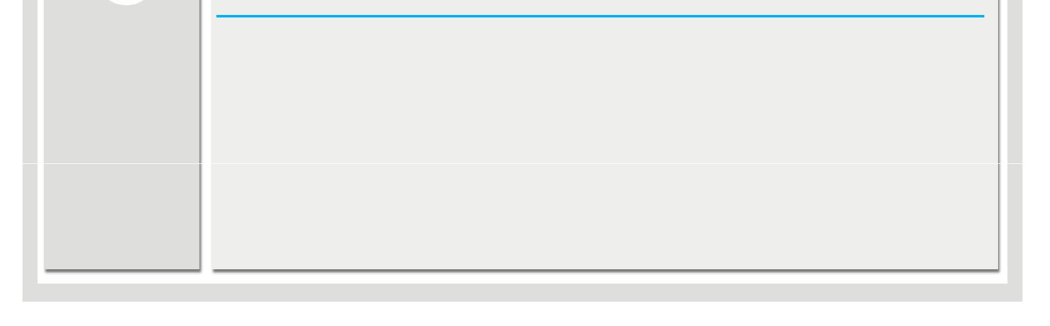

I hereby certify that the above information are true and correct to the best of my knowledge and belief.

Babu

