SEAN SEAN.369186@2freemail.com

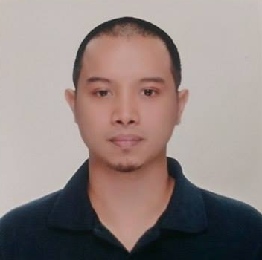  About Me  DOB & PLACE:  March 19, 1987  Manila, Philippines  Height: 162 cm  Visa Status :  Long Term Visa  Nationality:  Filipino  Language:  English and Tagalog  Education  College:  TRINITY UNIVERSITY OF ASIA  BS in Hotel and Restaurant Management  Philippines  Year 2004 - 2008  Skills:  Food safety understanding.  Food handling knowledge.  Able to work in fast paced environment.  Organized, independent worker with strong time management skills.  Detail-oriented and able to learn new tasks quickly and effectively. | Position Desired: Kitchen Staff / Commis Chef  OBJECTIVE:  Looking for any position of kitchen staff based on my past working experiences. To work for a well stable hotel kitchen and to improve my skills and knowledge in this field.  Competency Summary:  Experiences:  BERNHARD SCHULTE SHIPMANAGEMENT - MANILA, PHILIPPINES  Seafarer (Messman) - 7 years and 2 months of sea service worldwide.  DON HENRICO'S RESTAURANT - CAINTA, PHILIPPINES  Dining Staff - 6 months of service as a waiter.  Duties and Responsibilities:  - Assist Chief Cook in his cooking duties.  - Prepare additional variety of meals on scheduled tasks.  - Serves food in all personnel and guests as well.  - Observes proper cleanliness either personnel or in the over-all upkeep of the Galley and Mess room.  - Perform such function as may assigned to him by Chief Cook.  - Clean all alleyways, mess room, provision room, pantry, senior officers cabin, kitchen implements and utensils.  Seminar and Trainings:  TESDA NCR - MANILA, PHILIPPINES  National Certificate 1 in SHIP'S CATERING SERVICES (MESSMAN)  February 05, 2014  ASIAN INSTITUTE OF CULINARY ARTS - MAKATI, PHILIPPINES  Specialty Cuisine (European)  March 12, 2012 to March 16, 2012  BSM MARITIME TRAINING CENTRE - MANILA, PHILIPPINES  Seachef  April 13, 2009 to May 08, 2009  PERA (NEVILLE CLARKE) - MANILA, PHILIPPINES  Understanding the HACCP + Food Hygiene (ISO 22000 FSMS)  April 20, 2009  Job Description:  - Develop, prepare and service multicultural recipes and menus ensuring consistency in taste and presentation of all food items according to the hotel standards.  - Maintain daily mis-en-place and prepare certain food items for the following days duties.  - Ensure freshness of food and ingredients by checking for quality, keeping track of old and new items, and rotating stock (FIFO).  - Inspect and clean food preparation areas, such as equipment and work surfaces, or serving areas to ensure safe and sanitary food-handling practices.  - Ensure food is stored and cooked at correct temperature by regulating of ovens, broilers, grills, and roasters.  - Monitor related equipment, reporting any problems or inconsistencies to the superior.  - Maintains a clean and safe working environment.  - Performs other related duties as required.  I hereby certify that the above information is true and correct to the best of my knowledge and capabilities.

