RESUME

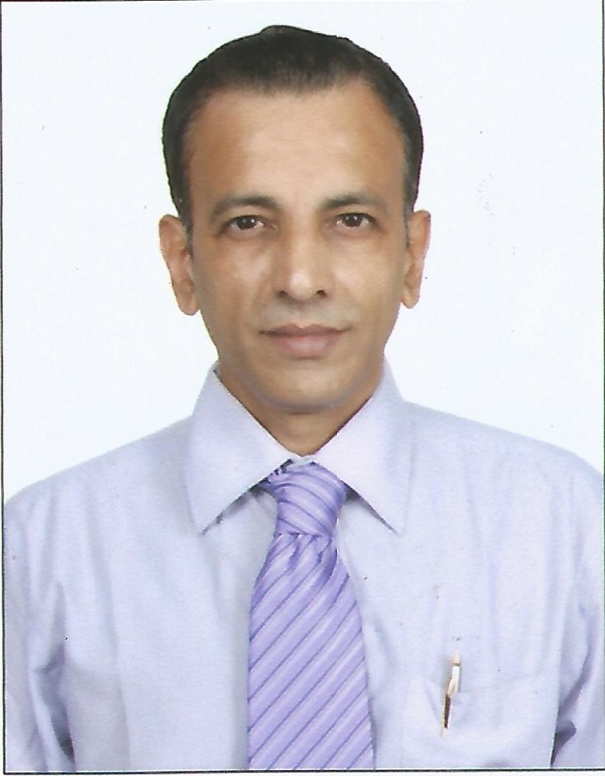 | Visweswaran  Visweswaran.369189@2freemail.com

DATE OF BIRTH : 18-11-1965

LANGUAGES KNOWN : TO READ, WRITE & SPEAK: ENGLISH, HINDI, MARATHI, TAMIL
TO SPEAK: GUJARATI & KANNADA
EDUCATIONAL : B.com.
QUALIFICATIONS Completed diploma course in Import & Export management through EXIM Management institute of Andheri, Mumbai (India).
I am well versed with Computer operation & also possess sound knowledge of operation of office equipments like, fax, telex etc.

EXPERIENCE: A) I was working as “Sr.Customer Service Executive” with Delta Commercial Brokers LLC., (Outsource agent for Call Centre for Citibank) in Dubai, UAE since November, 2008 till September, 2011.

My basic responsibilities mainly comprises of solving all kinds of customer queries with regards to the products dealt with by the company.
However, Apart from the above I possess the following capabilities:

IMPORTS: Sourcing of raw material, establishing L/C on the basis of
the order confirmations/orders/indents etc.., follow – up with shipper for shipping details and documents and related follow-up with CHA/Customs/Bank etc..
On receipt of import documents preparation of necessary documents required by CHA to clear the import consignment/s.
Follow up with bank for import payments/remittances and related submission of bank documents for the same.
EXPORTS:
Scrutinizing the L/C/s and asking for any amendment required.
Sourcing of materials as per Buyers order/s in case merchant exporting, Managing logistics, negotiating and booking with the Shipping co for Export cargo/es in the ship directly or through Freight broker/s.

Contd…2

….2….

Preparation of relevant documents as per L/C Terms.
Follow up with factory or supplier for timely delivery of goods for export.
Preparation of related documents for clearance of goods from customs etc...
Follow up with the CHA/shipping co for loading of export goods and subsequent obtaining of shipping documents.
Post shipment documentations like for claiming of Central Excise
Rebate / obtaining Proof of Export/s, claiming Duty drawback
(through CHA/ Agent) etc..
Follow up with Customs / CHA / Jt. D.G.F.T., / RBI /Export Inspection Agency etc...
Filing of Monthly ECGC Returns.
Follow up with overseas buyers for timely payment and subsequent obtaining of Bank Certificate for Export and Realization from the bank/s.

- I was working as“Documents-in-Charge” with a reputed Garments Manufacturing & Exporting company in SAIF ZONE, Sharjah, UAE dealing in Importing Fabrics and Processing Garments and exporting the same (mainly to European) & other countries from 01st November,.2007 to 05th February, 2008.

- Worked with M/s.ALLANA COLD STORES LTD (A Division of ALLANASONS LTD 100% EOU) at Fort, Mumbai,(INDIA) dealing in Meat and Marine Products and other consumable products in the Capacity of “EXPORT EXECUTIVE” under Marketing Dept., (since 04th December, 2006 to 31st July, 2007).

- Worked with M/s. GARWARE POLYESTER LTD., Vile Parle (East), Mumbai (INDIA) A Govt. Recognized Export House (Ltd.Co.) dealing in Polyester Films for various applications, as “EXPORT EXECUTIVE” for 7 years (since November 1998 to June, 2005).

(D) Worked with a reputed Govt. Recognized Trading House M/s. Sopariwala Exports, Nariman Point, Mumbai, (INDIA)
dealing in export of Tobacco leaves and Spices, Rice, Turdal etc.
as “Export Executive” (since August. 1997 to October, 1998).

(E) Worked with a reputed Export House – M/s. Indian Extractions Ltd., at Fort, Mumbai, (INDIA) dealing in Manufacture and export of Dye intermediates as “Sr. Import – Export Officer” for 7 years (since March, 1990 to July, 1997).

XXX----XXX

