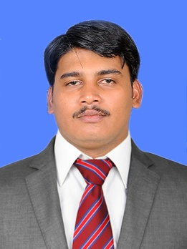Curriculum Vitae

IBRAHIM
IBRAHIM.369234@2freemail.com

Profile:
Professional Qualifications

- Web & Graphic Designing
Linspaire IT Solutions – Kinfra Techno Park Kakkancheri
- CCNS (CMS Certified Network)
Through CMS Computers – Calicut,kerala,india
- Computer Proficiency
(MS Word, Excel, Power Point, Corel Draw, Adobe Photoshop, Adobe Dreamweaver, Net Browsing)
- Professional Photography & Model Photography
(Iris Digital Color Lab Studio Manjeri, Kerala, India)

Employment History

1.
DURATION | March 2008 to February 2009
LOCATION | Calicut, Kinfra Techno Park, Kakkancheri
COMPANY | Linspire IT Solutions pvt ltd
POSITION | Web & Graphic Designer

  - Duties & Responsibilities
- Web Developing & Designing
- Designing Logo & Brushers
- Resolving Complaints.

  - Interfaces with:
- Staff
- Team Leader
- Customers

  - Operating systems:
- Windows – 2003 and 2008 -Server, Win-2000, XP, Vista, and Seven

2.

DURATION | December 2009 to December 2011
LOCATION | Kizhisseri,kerala,India
COMPANY | Walkin Computer Hardware& Network service Center
POSITION | Hardware& Network Technician

- Duties & Responsibilities
- Identifies problem sources to resolve hardware and software failures and malfunctions.
- Handle initial troubleshooting on network connectivity and performance problems.
- Provides technical support to users regarding hardware, software, and network related problems
- Performs network administration functions including creation, deletion, maintenance, and assignments of rights to users, groups, and shared files.
- Assists in optimizing computer and network performance and monitors the network to ensure reliability and availability.

- Interfaces with:
- Managers and Supervisors in Sections
- Staffs
- Customers

- Operating systems:
- Windows – 2003 and 2008 -Server, Win-2000, XP, Vista, Windows 7 and Windows 8.

3.
DURATION | January 2012 to February 2016 | 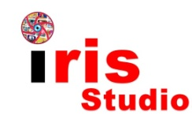
LOCATION | OPR Building, Areacode, Malappuram Dt, Kerala, India
COMPANY | IRIS Studio and Color Lab
POSITION | Photographer & Graphic Designer

  - Duties & Responsibilities
- Graphic Designing
- Designing Logo & Brushers
- Resolving Complaints.

  - Interfaces with:
- Staff
- Team Leader
- Customers

  - Operating systems:
- Windows XP, Vista, and Seven, Win 8

Projects

- PXE enabled booting and their implementation in Red hat Linux
- NFS, FTP, DHCP, DNS and Samba servers in Red hat Linux
- Provided IT infrastructure for Ayurvedic hospital (Windows platform)
Details:
- Implemented LAN, configured WAN, Enabled Wi-Fi, Facilitated Roaming users to access IT resources.

Academic Qualifications

- Higher Secondary Education, +1, +2 (Commerce) with first division in March 2008 Higher Secondary Examination board of Kerala, India
- Secondary Education, SSLC in the year March 2005 from Ebenezer, Ettichuvadu, Ranny, Secondary School Examination, kerala, India

Personal Information

Date of Birth : 05th July 1988
Nationality : Indian
Marital Status : Married
Religion : Muslim
Languages Known : English, Hindi, Tamil, Arabic and Malayalam

Declaration

I confirm that the information provided by me is true to the best of my knowledge and belief. Necessary documents will be produced as per the requirement.

