BIO DATA
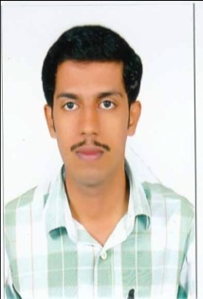

FAISAL

FAISAL.369296@2freemail.com

Languages known
English
Hindi
Malayalam

References
Available on request

Career Objective:
To seek challenging tasks that match my potential to deliver innovative ideas to achieve goals and also self development to contribute my might to the organization and grow in tandem with the organization in my pursuit of career advancement especially in finance.

WORK EXPERIENCE

Accountant & secretarial assistant

The Western India Ply woods Limited Valapattanam, kannur Kerala
(Nov 2013 to Nov 2016)

- Manage financial transactions and record keeping with strict attention to deal
- Office administration
- Preparation of monthly financials- statement of income, financial Position and cash flow.
- Handling petty cash.
- Preparation of purchase vouchers, payment vouchers, invoices
Debit & Credit notes.
- Monitored and recorded company expenses.
- Secretarial functions.
- Board Meeting workings.
- Listing with NSE.
- Distribution of Dividend.
- Preparation of minutes

EDUCATIONAL QUALIFICATION
- M Com Madurai Kamaraj University -2010
- B Com with Co-operation from Calicut university-2008
- Higher Secondary Education from Board of Higher
Secondary Examination of Kerala -2005.

PROFESSIONAL QUALIFICATION
ICMAI (inter) Institute of Cost and Management Accountants of India 2010

COMPUTER SKILLS

- Tally & FOREIGN ACCOUNTING
- VISUAL BASIC
- M S OFFICE

ATTRIBUTES AND STERNGTHS

- Flexible and can lead a team efficiently.
- Willingness to learn, flair to work hard.
- Enjoy the experience of belonging a team , working together to achieve a common goal
- Able to take responsibility, and trustworthy.

DECLARATION

I hereby declare that all the above furnished are truth up to the best of my knowledge and belief.

