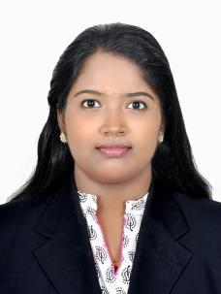

AISWARYA

AISWARYA.369297@2freemail.com

CAREER OBJECTIVE

To seek a challenging position in a dynamic environment and desire to progress further and to grow with the organization, prove to be an asset for its effective functioning and be a team player for the achievement of goals and the organization.

ACADEMIC RECORD

- M.com (finance) year- July 2014 - March 2016 from Calicut University.

- B.com (cooperation) year July 2010 –March 2013 from Calicut University.

COMPUTER KNOWLEDGE

- PGDCA, Tally

WORK EXPERIENCE

Caweri Trading, Dubai, UAE- Receptionist cum Admin Assistant (1st Feb 2017 to 24th April 2017)

- Data Entry

- Welcomes visitors by greeting them, in person or on the telephone; answering or referring inquiries.

- Maintains safe and clean reception area by complying with procedures, rules, and regulations. Maintains continuity among work teams by documenting and communicating actions, irregularities, and continuing needs.

- Following up with clients

Angel guard electronics, Palakkad, Kerala- Receptionist cum Admin (1st Aug 2013 to 31st Mar 2014)

Responsibilities

- Data Entry

- Welcomes visitors by greeting them, in person or on the telephone; answering or referring inquiries.

- Maintains safe and clean reception area by complying with procedures, rules, and regulations. Maintains continuity among work teams by documenting and communicating actions, irregularities, and continuing needs.

- Petty cash handling

Personal Details

DOB | : | February, 23rd 1993
Marital status | : | Married
Nationality | : | Indian
Visa status | : | Residence visa (husband sponsorship)
LANGUAGES KNOWN | : | English, Tamil, and Malayalam
Personality Traits

Quick to grasp Information, Can easily adapt to changes, a very dedicated worker. Ability to work under pressure commitment. Positive thinking and confidence in achieving the target.

Declaration:

I hereby declare that the information given above is true to the best of my knowledge and belief.

