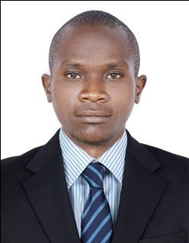
CURRICULUM VITAE

PERSONAL DATA.
NAME IVAN
NATIONALITY UGANADAN
DATE OF BIRTH 27/O6/1993
GENDER MALE
EMAIL ADDRESS ivan.369341@2freemail.com
MARITAL STATUS SINGLE
VISA STATUS VISIT VISA

CAREER OBJECTIVES.
I am dedicated, hardworking, flexible and self motivated individual seeking for a career with a multi-national organization or company to work as a team on inter-personal relations in order to establish a high sense of satisfaction and achievement by positively contributing to the welfare of the people and progress of the company or organization.
PRESONAL TRAITS.
- High level of self motivation and result driven personnel.
- High level of communication skills.
- Strong sense of responsibility with perfect dedication.
- Excellent knowledge of customer service.
- Able to copy with high demanding business environment.
EDUCATIONAL BACKGROUND.

- IRMA PFEIFFER HIGH SCHOOL 2013 Uganda Certificate of Education (UCE).
- NABUMALI PRIMARY SCHOOL 2010 Primary Leaving Education (PLE).

WORK EXPERIENCE.
- MBALE RESTORT HOTEL (Uganda)
SECURITY GAUD FROM 2014.S SEPT TO FEB 2017.
Provide excellent service to customers and responsible for all services related. My responsibilities included and were not limited to the following,
- Giving directions to customers to their desirable destinations.
- Assisting in administrative office work
- Sending and receiving emails or mails
- Maintaining office files and records
- Attending to clients complains and handle them to the management.
- Updating the data in the main database.
- Attending to customers complaints.
- Safe guarding customers and premises

- ACHIEVEMENTS

- International working experience
- Good illustration of directions and needed services
- Self-supervision
- Ability to lead others and good command of instructions
- Deliver good dedications

- LANGUAGES.
- English, Swahili, luganda and others.
HOBBIES.
- Playing and watching football.
- Swimming.
- Surfing the internet.
- Watching movies.
REFERENCE.
Available upon request.

