JEENA

Email ID: jeena.369413@2freemail.com
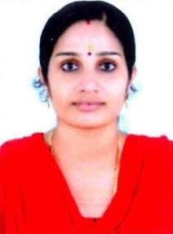
SUMMARY

Supplies loving care while making sure to meet disciplinary and educational goals for each child. Offers children clear guidelines that promote positive behavior patterns. Master science holder in Geology and Bachelors of Education in Physical Science with Four year Experience in Teaching field.

HIGHLIGHTS

- Lesson planning expertise.  - Common care knowledge.  - Strong interpersonal skills. | - Staying in Sharjah with Family Visa.  - MS office proficient.  - Family oriented.

ACADEMIC PROFILE

B-Ed - PHYSICAL SCIENCE.
PASSED WITH 62.6%
KANNUR UNIVERSITY (2011).

M-Sc - GEOLOGY.
PASSED WITH 64.33%
KANNUR UNIVERSITY (2010).

B-Sc - GEOLOGY.
PASSED WITH 66.4%
KANNUR UNIVERSITY (2008).

EXPERIENCE

- One year experience as Higher Secondary School Teacher in Geology.
- Three year experience as High School Teacher in Physical Science.

PERSONAL INFORMATION

Personal Data

Date of Birth : 16-10-1987
Sex : Female
Nationality : Indian
Marital Status : Married

Language Proficiency

English, Malayalam.

Passport Details

Date of Issue 23 FEB 2016
Date of Expiry 22 FEB 2026

DECLARATION
I hereby solemnly declare and affirm all the above particulars & information are true & correct and that I have not knowingly withheld any facts.

Yours Faithfully

Jeena

