 | SAYED  sayedrahis@2freemail.com | 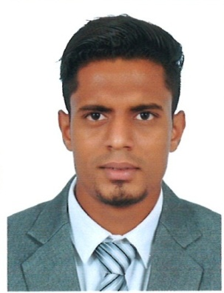
Career objective:-
- To be a part of an organization where the management rewards performance honesty and ambition of an employee that gives me a scope to update my knowledge and skills.
- To be a part of team working towards the growth of the organization.
- It is hereby learnt by me that a challenging and a great opportunity from your prestigious and esteemed organization is looking for a suitable candidate to serve your organization, so I present myself to you to be kind enough to give me an opportunity to serve in your organization. I can prove myself as a valuable asset to your company in all aspect
Personal profile:

Date of birth : 23th February 1993

Gender : Male

Nationality : Indian

Marital Status : Single

Blood Group : A+

Languages known : English, Hindi, Konkani

Visa Status : Visit

Visa Expiry : 20/06/2017

Skills:
Exceptional communication skills | Team Player
Customer Service Specialist | Hardworking & Dedicated
Trusted key holder | Quick learner

Details of work experience:
Company Name | Designation | Place
Air Arabia (National Aviation Service Pvt Ltd.) | Customer service agent | Goa International Airport India
Air India | Customer service agent | Goa International Airport India
Mormugao Port Trust | Customer service agent Cruise Line | Vasco, Goa, India
Work Description:
- Handling check-in counters.
- Handling duties pertaining to boarding gate.
- Handling arrivals.
- Handling on board duties.
- Guiding and interacting with the passengers from different nationalities with their queries and other related task
- Meet and assist
- Baggage handling
- Ramp operations
- Airport Announcements
- Attending phone calls
- Cruise traffic operations
- Carrying out other commercial duties.

Educational Qualification:
Institution Name | Degree | Address | Grade/Class
Rosary College of Commerce and Arts | Bachelor of Business Administration Specialised in Travel and Tourism(2013-2016) | Navelim Salcete Goa India | First class (Grade B)
Courses & trainings:

- Passenger and baggage handling course.
- Aviation Security Training programme.

Achievements:
- Received appreciation from group head of ground operations, regional manager and Airport manager of Air Arabia.

Declaration:
I hereby declare that the information provided above is true to the best of my knowledge and belief.
I understand that in the event of any information being found false or incomplete candidature/appointment is liable to be cancelled/terminated

SAYED

