RESUME
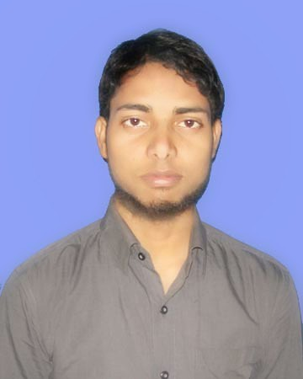

SHAHID ,
E-Mail: shahid.369503@2freemail.com

TOTAL EXPERIENCE: 3 YEARS EXPERIENCE

Post applied: Electrical Engineer

OBJECTIVE
Seeking a technical position in an engineering organization that would benefit greatly from my technical knowledge and personal skills and provide me with a solid development opportunity in a fulfilling career as an electrical engineer.

SYNOPSIS

- Experience 3 Years in construction(MEP) Project

- Currently working as a Electrical Design engineer having experiences in construction. Performing difficult technical work supervising and scheduling the installation ,and maintenance

- Identification of cost saving measures and implementation in coordination with other Engineers and An effective communicator with ability to relate technical knowledge to a non-technical audience.

WORKING EXPERIENCE

- Currently working as a Electrical design Engineer in M/S Subas Kumar & Co. Ranchi, Pvt ltd , Ranchi since March 2016 to till date.
- Worked as an Electrical Engineer since 10-01-2014 to 14-02-2016 in Kalpataru Power Transmission Ltd

JOB RESPONSIBLITY

- Selection of Transformer/DG capacity
- Electrical load schedule Preparation ,
- Circuit Breaker selection, Capacitor bank selection, cable sizing calculation, bus bar Earthing calculation,
- HT, LT cable sizing, Voltage drop calculations, Cable Schedule, Cable tray sizing and routine layout
- Short circuit & voltage drop calculation at each level of distribution ,
- Lux level calculation,
- Panel board design and main distribution board lighting and illumination design for commercial and residential complexes
- Prepare lighting layouts, power layouts, and Single line diagram.
- Preparing Single line diagram, Lighting, Power, Control and conduit layout., specification for electrical equipment such as transformer, energy meter, fuses, circuit breaker (MCB, MCCB), capacitor bank, RYB cables, voltage drop calculation, distribution boards ,etc.
- Technical proposals preparation, BOQ and report writing related to power and energy.

MAJOR PROJECTS INVOLVMENT
- Juslok Hospital iti Ranchi Jharkhand
- Itc Hotel project Hyderabad
- Trd Tula mall, Hyderabad

EDUCATIONAL QUALIFICATIONS

- B .Tech (Electrical & Electronic) JNTU, Hyderabad
- 12th (J.A.C Board) Marwari Collage Ranchi Jharkhand
- 10th (J.A.C. Board) KHSP Ranchi Jharkhand
IT FORTE

AutoCAD (Electrical) : Related to designing of Electrical System
Design software : CG LUX, RELUX.
Packages Known : Microsoft Office 2003 & 2007, Windows 8.1, 2007 XP, Vista,

BEYOND CURRICULUM

- Participated in Quiz competition in school festival. 2006
- Participated in Intra College Cricket tournament. 2009-10

PERSONAL SKILLS

- Self-motivated.
- Quick learning skill.
- Ability to adapt any environment or situation.
- I have the ability to cope with failures & try to learn from my mistakes
- Ability to deal with people diplomatically
- Ability to handle site independently
- Excellent team work experience

PERSONAL DOSSIER

Name : Shahid
Gender : Male
Date of Birth : 12/08/1993
Religion : Islam
Nationality : Indian
Marital Status : Single
Languages : English, Hindi, & Urdu
Date of issue : 27/02/2015
Date of expiry : 26/02/2025
Passport issue : Ranchi

Declaration:

I Shahid Eqbal hereby confirm that the information given above is true to the best of my knowledge and belief

Date:
Place: ` Shahid

