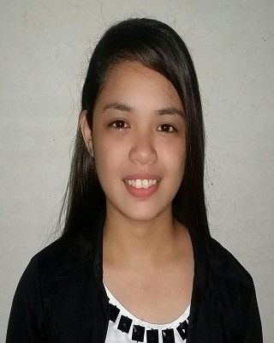
Erika
Email: Erika.369541@2freemail.com

Work experience

Hapitanan Beach Resort May 2014 — July 2015
Receptionist
Trained to welcome guest to the resort with hospitality.
Excellent in managing customer bookings as well as making strategy in coping up with customer's sudden change of plans.
Handling customers for all inquiries about the resort and giving proactive information that the customers might need.
Answering/forwarding calls and taking messages.
Demonstrated ability to deal effectively with phone inquiries.
Consistent in keeping work area clean and presentable to guests.
Convergys Philippine Corporation August 2015 — February 2017
Customer Service Representative
Managed a high-volume workload. Resolved an average of 350 inquiries in any given week and consistently met performance requirement.
Became the lead "go-to" person for new reps and particularly challenging calls as one of the company’s primary mentors.
Helped company attain the highest customer service rating high marks in all categories including communication skills, listening skills, problem resolution and politeness.
Officially commended for initiative, enthusiasm, tenacity, persuasiveness, intense customer focus and dependability in performance evaluations.
Completed voluntary customer service training to learn ways to enhance customer satisfaction and improve productivity.
Received high awards for services such as Circle of Champions, Top Agent, Best of the Best and Outstanding Performance Attendance.
Blusands Resort Inc. February 2017 — April 2017
Receptionist
Highly skilled in welcoming visitors and directing them to the right person or department.
Well-versed in managing guests booking both for walk in and reserved customers.
Hands-on experience in giving accurate information to visitors and answering their questions.
Answering/forwarding calls and taking messages.
Demonstrated ability to deal effectively with phone inquiries.
Able to maintain an organized reception area.
Comprehensive knowledge of organizing reading material in the waiting area.
Erika 1

Education

Bachelor of Science in Secondary June 2008 — April 2014
Education
Cagayan de oro College-PHINMA

Interests
Traveling- I like to interact with different people and experience their traditions and culture. I also love seeing different tourist spots and experience nature at its best.
Reading- I love reading informative books and novels. It is like traveling through time and places trough the mind of a great author. I like both prose and poetry.
Yoga- It allows me to keep equilibrium with bot body and mind.
Volunteering- Helping and giving back to the community and people in need gives me much joy. That's why i volunteer as much as I can to help improve the quality of life.
2

