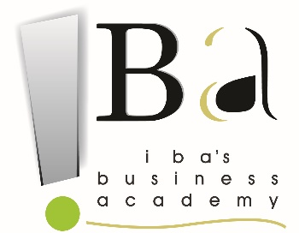

AKHTAR
Email: akhtar.369602@2freemail.com
 | Educational Qualifications
Degree |  | Institution | Score % / CGPA | Passing Year
MBA  (marketing) |  | Indus Business Academy, Bangalore  Approved by AICTE, MHRD, Govt. of India  Internationally Accredited by IACBE, Approved by CHEA, USA. | 55.86% up to 2^{n}sem | Pursuing
BBA |  | Keen College Bikaner  Maharaja Ganga Singh university | 63% | 2015
12th |  | DEV Public School  (Ajmer board Rajasthan) | 52.31% | 2012
10th |  | Sanskar Children Academy  (Ajmer board Rajasthan) | 48.17% | 2009

Summer Internship / Project Details
Company Name: APNA Paper mills Pvt. Ltd
Designation: Marketing Intern
Duration: 8th April 2016 to 21st August 2016
Project Title | Study of customer satisfaction
Project Highlights | Objective | - Gathering information about likes and dislikes of the customers  - Research about improving quality of product  - How to reducing the costs  - Increasing production flexibility
 | Outcome | 60% highly satisfied with the quality  65% of the customers are satisfied with after sales service.

Roles & Responsibilities

- Coordinator in blood donation camp at IBA campus
Key Academic Project
- Project on MUKESH HYUNDAI (RAJASTHAN) during my graduation
- Project report on brand building during my 1st sem of MBA
Skills
- Soft skills: Decision maker, self-motivator
- Technical Skills: MS Excel, MS Power Point, MS Access
Extra-Curricular Activities
- Playing cricket, table tennis
- Dancing

Languages known: Hindi, English, Urdu, Rajasthani

