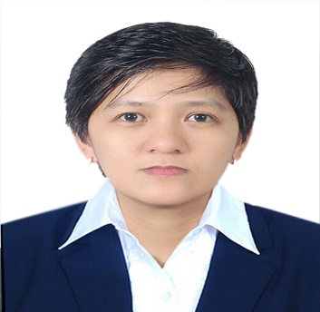
PRINCESS
Email: princess.369616@2freemail.com

CAREER OBJECTIVE:
To provide excellent customer service skills in any setting that can contribute to the attainment of the company’s mission and vision.

SKILLS
- Proficiency in oral and written English communication, basic computer skills such as Microsoft Word, Excel, and Powerpoint, basic accounting skills, and record keeping and office organization skills. Time management
- Ability to prioritize and execute task in a high pressure environment.
- Multiple priorities handling
- Highly organized and used to working to tight deadlines.

EXPERIENCE:

sales associate

MRF International general trading, llc (UAE) •

May 24, 2015 – janUARY 26, 2017
- Assists clients and ensures prompt and excellent customer service
- Maintains records of daily sales and expenses

sales associate
GLOBE TELECOM OPERATION
FEB. 01, 2014 – MARCH 10, 2015 PHILIPPINES
- Assisted cluster supervisor in day to day operations
- Assisted the supervisor on all Internal Administrative and after sales customer service
- Processed all agents (Direct Sales Personnel) paper works or documents
- Provided secretarial works to the supervisor when necessary; like preparing memos, minutes of meeting, and correspondence with the client and the management
- Monitored the daily operations of each agent and make sure that all Monthly Targets are being met to the highest standards
- Submit weekly reports to company’s Operating Manager and to the representatives of Globe Telecom

customer service personnel

nursing consultancy & development center (Philippines)

JAN. 15, 2008 – JAN. 24,2014

- Assists clients which includes giving prompt and accurate answers to their queries and providing customer assistance in various aspects
- Maintains records of clients’ individual and company files
- Encoding and editing of office documents using Microsoft Word, Excel and Powerpoint software applications

owner/manager • crism convenience store • 06/2001 – 01/2008

- Manages a self-owned small-scale business
- Engages in customer assistance
- Performs basic accounting skills

bs computer science • 1996-2000 •

mcn computer college, tuguegarao city, philippines
Completed 4-year academic requirements

secondary education • 1991-1995 •

northern cagayan colleges, ballesteros, cagayan, philippines
Graduated from a four-year secondary (high school) education

Gender: Female
Marital Status: Single
Nationality: Filipino
Date of Birth: January 18, 1978
Religion: Christian
Visa Status: Visit visa

