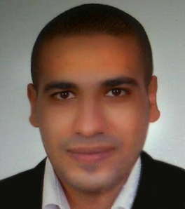
Personal data :
- Date of birth : March 19,1987
- Nationality : Egyptian
- Marital status : Married
Objective :
Seeking a challenging position where I can extend my capabilities and gain more experience and seeking accompany where I can use my experience and education to help the company meet and surpass its goals.
Qualification :
Bachelor social work -higher institute of social work, 2009.
Work experience :
- (2009:2011) sales and marketing representative -resort Arabian nights, Cairo branch.
- (2011:2012) sales and marketing executive for Advanced technology company for medical supplies & medical furniture
- (2012:2014) general supervisor and assistant manger Al-Zarwa Company in Doha-Qatar.
- (2014:2015) supervisor for El Safa tourism company.
- (2015:2017) sales and marketing executive for Neyvex Company.

Duties :
- Develop and maintain relation relationships with the team through support and marketing of product inquiries , and all general question.
- Provide pricing support to team.
- Create the collection packages, quotation and proposals and support the time ion closing business.
- Approval of plans of team work and the distribution of task.
- Provide monthly report on the results of sales and marketing.
- Follow up the problems and obstacles related to the work of marking and sales and after sales.
- Meeting .
Courses :
- Business and Time management.
- Individual psychology collective.
- Microsoft office course
- Adobe photo shop.
- Adobe illustrator.
Conference and seminars :
The annual general conference of the Egyptian society for family planning – national conference of the population – simmers of street children – religious seminars – simmers of dangerous of addiction – culture simmers – seminars leadership – human resource seminars.
Skills :
Language skills Arabic : mother tongue English : good
Computer skills -excellent user computer task .
-Excellent user Microsoft office .
-Good user adobe photo shop & illustrator.

Personal skills -quick learner.
-active and energetic .
-ability to work individual or as effective team member .
Flexibility and ability to mange priorities.
- ability to working under stress.
-active communication.
-leadership skill .
-creative.

Mahmoud.369660@2freemail.com

