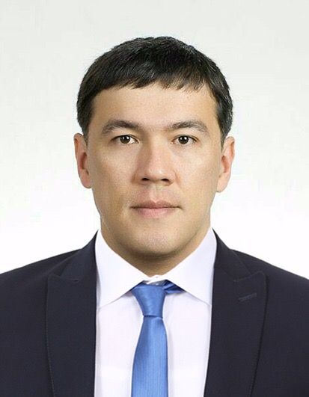
SHAVKAT

Email: shavkat.369688@2freemail.com
Nationality: Uzbekistan

PERSONAL SUMMARY

I come with 10 years of experience Retail and Customer Service in USA, RUSSIA , KOREA And UZBEKISTAN. I am looking for a position where I can advance in my career and contribute to the growth of the company I work for through my experience and hard work.

LANGUAGES
English (Fluent) Turkish (Fluent)
Russian (Fluent) German (Fluent)
Korean (Fluent) Uzbek (Native)

EXPERIENCE
Sales Assistant - “Kumdo universal” Ltd , Seoul, Korea
- Conduct market research to identify selling possibilities and evaluate customer needs
- Actively seek out new sales opportunities through cold calling, networking and social media
- Set up meetings with potential clients and listen to their wishes and concerns
- Prepare and deliver appropriate presentations on products/ services

Sales Assistant – “Dairy production” , California , USA

- Visiting potential customers for new business and developing and maintaining relationships
- Making accurate cost calculations to provide customers with quotations
- Negotiating the terms of an agreement with a view to closing sales

Sales Representative – ‘SKAZKA’ Boutique, Moscow, Russia

- Provide professional till point service to close the sale and offer the customers an overall enjoyable shopping experience.
- Handle customer complaints professionally and escalate any serious issues to the Manager for suitable resolution.
- Maintain an up-to-date database of customers visiting the store.
- Communicate to the customers the information on special offers/sales promotion events.

Waiter - ASIA Hotel, Tashkent, UZBEKISTAN

- Preparing tables for a meal
- Present menus to patrons and answer questions about menu items
- Taking customers' orders
- Serving drinks and food
- Cleaning up before, after and during servings in a restaurant
- Ensure minimum wastage, spoilage of food and drink.

EDUCATION

Uzbek State World Languages University, Bachelors degree.

Thank you for taking the time to consider this application and I look forward to hearing from you in the near future.
Yours sincerely,
Shovkat.

