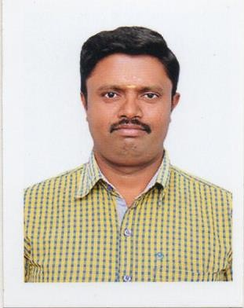

Jaiganesh
Email: jaiganesh.369706@2freemail.com

CAREER OBJECTIVE:

To obtain a respectable position in an organization which will enable me to use my talents knowledge and ability to the maximum and contribute to the growth of the organization as well as myself.

CORE QUALIFICATIONS
    - Exceptional problem-solving abilities Excellent written and verbal communication skills
    - Strong ability to prioritize and multitask duties
    - Focused attention to detail
    - Above-average organizational skills
    - Excellent customer-service focus
    - Thorough knowledge of current export and import regulations and laws

PROFESSIONAL PROFILE: AKASH PET CONTAINERS (P) LTD DMS BOTTLES

(From Jun 2012 to Jan 2017)

POSITION: FINANCE

Roles handled- (Finance)

    - Ensure that sufficient funds are available to meet ongoing operational and capital investment requirement.
    - Preparing financial reports (Balance Sheet, P & L and Cash Flow statement).
    - Ensuring the cash flows is adequate to allow business units to operate effectively.
    - Manage the payroll activities
    - Maintains the banking transactions up to 2 million per month.
    - Financial audit / closing of accounts
    - Inventory Verification
    - Recommend and maintain a system of policies and procedures that impose an adequate level of control over Finance and Accounts department activities.
    - Analysis of income and expenditure.

INDCO TEA FACTORY OOTY

(From Oct 2006 to May 2012)

Roles handled- (Finance)

    - Managing day to day accounts activities-Cash, Bank, Accounts Payable & Receivable.
    - Security & Data entry updating of Cash & Bank vouchers.
    - Collecting bills, passing entries, payment to vendors and employees..
    - Preparing Bank Reconciliation Statement on a monthly basis.
    - Payment to Warehouse for keeping stock until auction.

CITI BANK - Coimbatore

(From June 2004 to Sep 2006)

    - Personal Loan (Customer Eligibility & Verification )
    - Car loan (Customer Eligibility & Verification )

SKILL PROFILE:

    - Good communication skills with people of all levels and roles
    - Ability to be strategic and tactical and to work as a team with drive and energy
    - Ability to handle high net worth clients.
    - Recognized as creative and fast practical problem solver
    - Enthusiastic, creative, and willing to assume increased responsibility
    - Personable, articulate, and professional in both appearance and manners
    - Experienced in balancing priorities for short-term and long-range goals
    - Ability to learn fast and a never say die attitude – optimistic
    - Good knowledge in finance and accounts
    - Can turn ‘a smile’ into business

ACADEMIC QUALIFICATIONS:

    - Completed B.Com. Degree in Commerce (Accounts) in the year 2004 from Hindustan College Bharathiar University (First class Distinction).
    - Completed Diploma in Commercial (Practice) in the year 2002 from Hindustan College Bharathiar University (First class Distinction).

COMPUTER SKILLS:
    - PGDCA
    - Visual Basic,
    - Microsoft Word, Excel, working knowledge of PC platform.

LAUNGAGES KNOWN: English & Tamil.

PERSONAL DETAILS

Date of Birth : 25.05.1981
Nationality : Indian
Gender : Male
Marital Status : Married
Availability : Immediate
Visa Status : 3 Months

DECLARATION

I hereby declare that the above given particulars are true and correct to the best of knowledge and belief.

(JAIGANESH)

