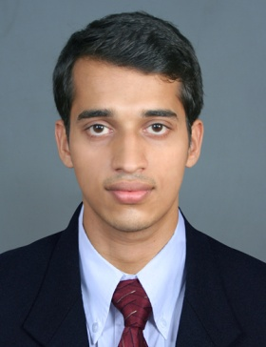
TIVIN

Tivin.369728@2freemail.com

OBJECTIVE
I foresee myself as an effective contributor to an organization that has to face a dynamic business environment offering phenomenal opportunity. I am keenly interested in taking up a challenging assignment and exploiting my earnest support and customer support skills to meet personal, business and corporate objectives.
EDUCATION DETAILS
- B.sc. THM Bachelor of Science and Catering tourism and Hotel Management
In the year 2006 – 2009 by Madurai Kamaraj University.

PROFESSIONAL EXPERIENCE
- Presently working in Claridge Hotel Dubai as Guest Service Associate from july 9-2015
- Windsor Castle as Guest Service Associate from Feb. 20-2014 to June 30-2015
- Fine Dinning Naif Chicken Restaurant, Kuwait Guest Service Associate Oct 2012 –Jan -2014
- Soma Kerala Palace Kerala Guest Service Associate -Oct -2010 Jun -2011
- Contour Back Waters , Kerala Guest Service Associate –Mar -2010 Sep-2010
- 8Months Job training experience in Food &Beverage service at Hotel VAIDYA ,Kerala -may-2009 –Dec 2009
JOB DESCRIPTIONS HANDLED
- To work as a team and to improve my personal performance ,hence improving the quality of F&B service for the organization
- Ensured that all customers were treated friendly and effectively.
- Planned work schedules and the assignment of employees for an efficient operation.
- Manage the preparation and storage of the various foods which are listed the menu.
- Ensured selling opportunities are increased, with the guests consent
- Attending and keeping customer happy

- Taking orders for restaurant and billing
- Greeting guests and seating them comfortably
- Handing the special orders in restaurant
- Co-ordination with kitchen quick service
- Focus on special emphasis on priority and VIP guests

PERSONAL PROFILE
Date of Birth : 17.06.1987
Nationality : Indian
Gender : Male
Marital Status : Single

SKILLS &KNOWLEDGE
- Microsoft Word Excel
- Languages Known : English ,Malayalam ,Tamil , Arbic
INTERESTS&HOBBIES
- Traveling , listening music

Declaration
I hereby declare that the above furnished in formation’s are true to the best of my knowledge and conscious.

Place: Kerala
Date:

TIVIN

