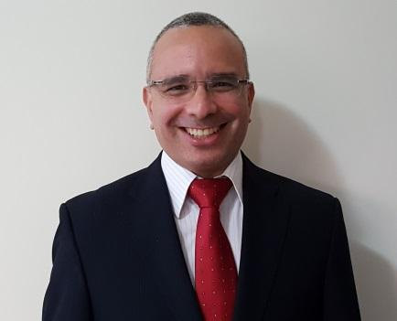
Fábio
E-mail: Fabio.369763@2freemail.com
SKILLS
Applying Mathematical knowledge
More than 14 years applying knowledge in statistics, logic, financial mathematics in the financial market

Financial education programs
Made decisions about education curriculum, organized materials and led lectures

Critical thinking
Daily analysis of trends to make crucial decisions

Team leadership
Led various projects working with diverse groups

Technology
Advanced Training in MS Excel, C and VBA programming languages, and electronics

Adaptable
The dynamic day-to-day in financial market requires an open mind and a large capacity for fast paced changes

EDUCATION/QUALIFICATIONS
- 2006 Mathematics/ B. Ed, University of São Paulo (USP), Brazil
  - Faculty of mathematics - # 10 World Rank
  - University of São Paulo - # 120 QS World University Rankings

- 2006 Teaching Qualification Grades 7-12, University of São Paulo (USP), Brazil
  - E.E. Oswaldo Aranha, (6 months)
    - Taught grades 7 & 8 Integrated Maths

- 2007 English language course, St. Giles English College, London

CERTIFICATION
- 2012 Anbima CPA 20 Brazilian Financial Market Certification

EXPERIENCE
- 2008-2016 Private Tutor, Part Time
Mathematics/MBA preparation
  - Private lessons for ages 15-25 aimed for mathematics preparation courses – Algebra, functions, geometry, probability, statistics and finance

- 2010-2016 Metrus: Brazilian Pension Fund
Financial Educator/Investment Analyst
  - Preparation and development of financial education program
  - Developed investment analysis reports
  - Member of investment committee (US$ 540 million under management)
  - Investment portfolio management with bonds, treasures, corporate credits, funds, equities

- 2008-2010 Bufallo Investments
Investment Analyst
  - Private equity process assistant
  - Operated valuation system

- 2003-2007 Mercer Investment Consulting: International Investment Firm
Investment Analyst
  - ALM (Asset Liability Modeling) studies - Preparation of materials for clients and meetings
  - Responsible for monitoring team
  - Risk and performance analysis
  - Monitoring of strategy and investment management

PERSONAL INFORMATION
- Citizenship: Brazil
- Status: Single
- Birthdate: June 1, 1977
- International exposure: 20+ countries
- Languages:
  - English (Fluent), Portuguese (Fluent), Spanish (Intermediate)
- Community Service:
  - Associação Minha Rua Minha Casa (AMRMC), homeless organization
  - Lar dos idosos, elderly care facility
- Hobbies: Investment club, Formula 1, movies, go karting, karaoke

