Resume
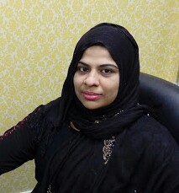
Jasiya  : jasiya.369769@2freemail.com  Post applied for: Admin Staff / Accounts Assistant | 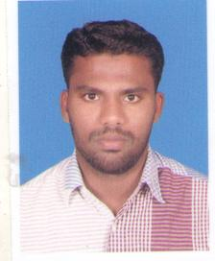
Career Objective  Administrative support professional offering versatile office management skills and proficiency in Microsoft Office programs. Strong planner and problem solver who readily adapts to change, works independently and exceeds expectations. Able to juggle multiple priorities and meet tight deadlines without compromising quality.  Educational Qualification  - Master of Computer Application (MCA) from Annamalai University 2013 Passed, Tamilnadu, India.  - Bachelor Degree in Computer Science (BSc) from Vivekananda Arts and Science College for Women 2011 Passed, Tamilnadu, India.  - Higher secondary examination from St.Pauls Girls Higher Secondary School 2008 Passed, Tamilnadu, India.  Interested Field  - Take interest for all aspects of the day to day running of the filing, copying, report writing, and invoicing jobs.  - Interest to handle the telephone enquiries.  - Make daily work plan of seniors with proper timing.  - Manage the daily incoming of the customers.  - Manage the documents in proper way.  - Handle all the other responsibilities related to the job.  Academic Projects Details  - Credit card transaction.  - Educational loan management.  Major Computer Skills  - Well versed in Microsoft Office Suite (Word, Excel, PowerPoint, Outlook, Project, Access).  - Skilled with Adobe Illustrator and Photoshop  - Highly Proficient with QuickBooks.  Visa Status  - Visa Type : Resident Visa (Husband’s Visa)  Personal Strengths  - Compressive problem solving abilities  - Team working abilities  - Quick learner  - Proficient in oral and written communication  - Highly motivated energetic, reliable and experienced in leading a task force  - Well organized , disciplined and hard working  Self-Evaluation  Being an ardent team player and hardworking person, I believe teamwork is the secret to success. I am capable of adapting to any changing work scenario and am keen to learn new things and accept new responsibilities. |  | PERSONAL DETAILS  Date of Birth :  01/07/1991  Age: 25 yrs.’  Nationality :  Indian  Religion :  Muslim  Languages Known:  - English (R,W,S)  - Tamil (R,W,S)  Marital status:  Married  Gender:  Female  Visa Status:  Husband’s Visa  PERSONAL TRAIT:  - Problem solving ability.  - Co-operative and Adaptability for any situation.  - Quick learn and good listening.  - Creativity and Technical mind.  - The motivation and desire to solve complex engineering issues.

