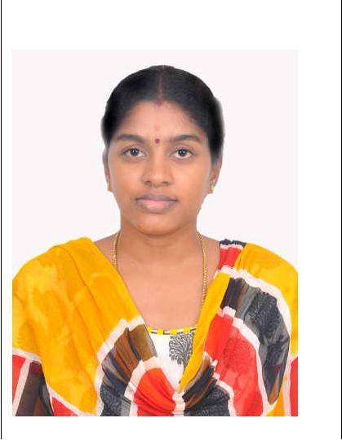
RESUME

APPLICATION FOR THE POST OF PHYSIOTHERAPIST.

SIVARANJANI

Email: sivaranjani.369816@2freemail.com DHA ELIGIBILITY Ref No : DHA/LS/18112015/528221

Career Objective:

Looking for a job in a reputed concern which enhances my skills and thereby

provides me an opportunity to contribute to the growth of the organization.

Objective:

To see a position where I could use my Physiotherapist skills and serve your organization to the best of my efforts with utmost sincerity.

Highlights of Qualifications

- Determine appropriate treatment for injury

- Accurately diagnose strains, sprains and ruptures. Evaluate physical recommendations.

- Determine appropriate treatment for Critical care unit

- Proper Maintenance of patients records till
- Determine proper Ergonomics after appropriate treatment
- Good Rapport with patients & Family members of patient

RESUME

Academic Qualifications:

DEGREE : BATCHELOR OF PHYSIOTHERAPIST

YEAR OF PASSING: AUGUST 2009

UNIVERSITY : Dr.M.G.R.MEDICAL UNIVERSITY,

CHENNAI, INDIA

COLLEGE : ADHIPARASAKTHI COLLEGE OF

PHYSIOTHERAPY

COMPULSORY RESIDENTIAL ROTATORY INTERNSHIP:

C.R.R.I training has been undertaken by the following institute,

1. | Orthopedics Department | : 3month
2. | Cardiothoracic Rehabilitation | : 15days
3. | Neurological Rehabilitation | : 15days
4. | Plastic Surgery, Hand Rehabilitation: 15days
5. | Rheumatology | : 23days
6. | Leprosy Rehabilitation | : 15days

DUTIES & RESPONSIBILTIES:

Initiate appropriate physiotherapy intervention programs for patients or clients suffering from immobility.

Assess and evaluate physical disabilities caused by neurological disorders, stroke, diseases or injuries.

Bring wellness and mobility in physical disabilities caused by injuries, stroke or other neurological disorders through physiotherapy treatment programs.

RESUME

Handle pain and physical problems caused by illnesses, disabilities and injuries. Manage and treat patients with disabilities in home and community care. Maintain and update patient records and documents.

Provide quality physiotherapy treatment to the highest possible levels. Teach patients and their families about self care treatment interventions.
- Performed spinal and peripheral joint mobilization and manipulation

- Use equipment including weights, traction, cold packs and electrical treatments to ease pain, improve range of motion and reduce swelling

- Retrain patients to walk

PROFESSIONAL EXPERIENCE:

Hospital Name : DR.Kumar’s Ortho Clinic,
CHENNAI-600044.

Formal Title : PHYSIOTHERAPIST
Start Date : 01-Sep - 2015

End Date : 31-Jan - 2016

Hospital Name : DR.C.R.PRAVEENKUMAR CLINIC(NEURO),
CHENNAI- 600122.

Formal Title : PHYSIOTHERAPIST
Start Date : 01- Jan - 2013

End Date : 31-Aug -2015

Hospital Name : DR.KAMATCHI MEMORIAL HOSPITAL,

CHENNAI-600100.

Formal Title : PHYSIOTHERAPIST

Start Date : January-1st -2010

End Date : 31-Dec-2012

RESUME

FIELD EXPOSURE

Cases Treated in the Following conditions.

Orthopedics conditions like.
Arthritis

Ligament Sprain
Muscles Strain

Disc Lesions

Surgical Cases (Joint Replacement/Internal Bone Fixation

)
Low back pain

Neurological conditions like. Hemiplegia

Paraplegia Parkinsonism Polio

Peripheral Nerve Lesion Cerebral Palsy

Surgical cases (Tumor Excision in Brain & Spinal Cord)

Cardiothoracic conditions like.

Surgical cases (open Heart& Close Heart Surgery,lobectomy,pneumonectomy,tumor excision around thoracic region)

COPD
Asthma

Lung abscess

Tracheostomy cases Bronchiectasis

Other condition like Renal transplant

Surgical cases(Nephrectomy, renal calculi removal) Laparotomy

General surgery

RESUME

PERSONAL DETAIL:

Name | : | SIVARANJANI
Date of Birth | : | 28/06/1986
Marital status | : | Married
Date of issue | : | 19/07/2010
Date of Expiry | : | 18/07/2020
Gender | : | FEMALE
Nationality | : | Indian
Languages Known | : | English, Tamil.
Declaration:

I hereby declare that the details furnished above are true to the best of my knowledge.

Signature

(SIVARANJANI)

