RESUME

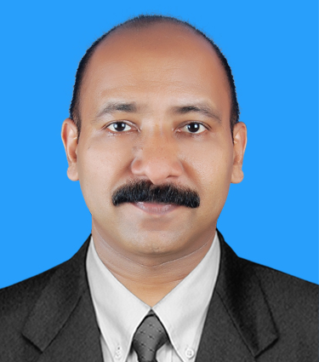  RAJEEVAN  E-MAIL:  Rajeevan.369942@2freemail.com  1Personal Details:  Date of Birth : 10/10/1970  Gender : Male  Nationality : Indian  Marital Status : Married  Having Valid UAE Driving License  Visa Status: Visit Visa | OBJECTIVE  Looking forward to a challenging position in a growth oriented organization which allows me to prove my professional expertise and also at the same time learn and progress towards greater heights.  CAPABILITIES  - Handling HR / Administrative / Payroll / PRO / Logistic functions.  - Strong organizational and interpersonal skills with determination, dynamism and leadership capabilities.  - Ability to adapt to new environments and willingness to learn.  - A record of having fulfilled all given jobs to satisfaction.  - Self motivated, aggressive and ambitious with a strong desire to succeed & make successful.  EMPLOYMENT HISTORY  - Worked as an HR / Admn. Coordinator in Tech International FZC (Galadari Brothers Group), Hamriyah Free Zone, Sharjah, UAE from January 2008 to February 2017.  - Worked as a Sr. Commercial Officer with Aquapharm Chemicals Ltd., Pune, India from April 2007 to December 2007.  - Worked as a Steno with Aquapharm Chemicals Ltd., Pune, India from March, 1999 to March, 2007.  - Worked as a Secretary with Pittie Agro Ventures Ltd., Pune, India from March, 1997 to March, 1999.  - Worked as a Steno Typist with Rajkumar Forge Limited, Pune, India from September 1994 to September, 1996.

NATURE OF WORK HANDLED
- Assist with day to day operations of the HR functions and duties
- Payroll preparation by providing relevant data (absences, bonus, leaves, etc). Familiar with Oracle HRMS.
- Generating attendance reports and monitoring records of in-out punching
- Overtime record keeping
- Arranging interviews / Preparing offer letters / Arranging flight tickets
- Arranging accommodation for workers and staff
- Renewal of Visa, Emirates ID, Medical Card, etc.
- Clerical and administrative support to Human Resources Head
- Compile and update employee records (hard and soft copies)
- Process documentation and prepare reports relating to personnel activities (staffing, recruitment, training, grievances, performance evaluations etc)
- Deal with employee requests regarding human resources issues, rules, and regulations
- Communicate with public services when necessary
- Conduct initial orientation to newly hired employees
- Working closely with various departments, increasingly in a consultancy role, assisting line managers to understand and implement policies and procedures
- Developing and implementing policies on issues like working conditions, performance management, equal opportunities, disciplinary procedures and absence management;
- Leave application processing / End of Service settlement process
- Keeping of confidential documents, other office files, correspondence, reports available for reference
- Travel booking as needed, including hotel booking
- Transportation arrangement for company staff and workmen
- General Office Correspondence
- ISO documentation
- Updating and informing Management regarding the policies and procedures with reference to UAE Labour Law.

- Hamriyah Free Zone Activity:
Supporting PRO for Visa related activities like Applying Visa, Renewal, Cancellation & License renewal, Passport Withdrawal etc.

Supporting Customs PRO for all Logistics related activities like Customs clearance, Export, Import, vehicle coordination etc.

Educational Profile

Bachelor Degree of Arts from Calicut University (1994)

Computer Knowledge
- Familiar with ERP / Oracle HRMS software
- Internet Browsing
- MS Word, Excel, Power Point
- Good typing speed

Languages Known
English, Hindi and Malayalam

