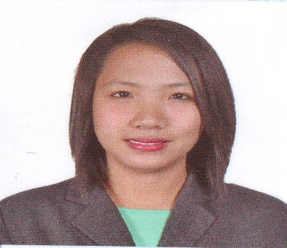
Elisha
Email: Elisha.370292@2freemail.com

Objectives

- To be the part of the attainment of goals and objectives of
- To work effectively and efficiently, abiding the rules and moral, righteous and ethical behaviors.
- To develop commitment in my work by giving passion in my molding as a competent Teacher.
Personal Profiles
Name: Elisha
Date of birth: July 8, 1987
Gender: Female
Age: 29
Nationality: Filipino
Civil Status: Married
Religion: Roman Catholic
Languages/Dialect you can speak or write: Tagalog(Filipino) and English

Professional Development Profile
Tertiary: Saint Mary’s University (SMU)
Bachelor of Science in Elementary Education
Bayombong, Nueva Vizcaya
Year Graduated: 2008

Bachelor of Science in Elementary Education (Specialization –
Preschool Education)
18 units
PLT College, Bayombong, Nueva Vizcaya June 2011- March 2012
Aldersgate College, Solano Nueva Vizcaya April-May 2011
Year: 2011-2012
PROFESSIONAL REGULATION COMMISSION
Licensure Examination for Teachers (LET)
License Number : 0889742
Registration Date : 11/23/2008

High School: Saint Mary’s University High School/Science High School Dept.
Bayombong, Nueva Vizcaya
Year Graduated: 2004
Elementary: Saint Mary’s University Elementary Department
Bayombong,Nueva Vizcaya
Year Graduated: 2000

Organizations joined

- Marian Dance Troupe June 2004-2005
Pre-Professional Experiences

- Student Assistant
Saint Mary’s University Elementary Department
2007

Work Experience

- Nueva Vizcaya Bright Child School
Bayombong, Nueva Vizcaya
Teacher Assistant (Kinder 1)
Year: 2008-2009

- Saint Louis School
Solano, Nueva Vizcaya
Classroom Teacher (Nursery and Kinder 2)
Year:2009-2010

- Tiny Tots
Bangkok, Thailand
Teacher Assistant (Kinder 1)
Year: 2010

- Nueva Vizcaya Bright Child School
Bayombong Nueva Vizcaya
Teacher Assistant 2011-2014 (Kinder 2)
Classroom Teacher 2014-2017 (Kinder 1)

Seminars attended

- The Leader in Me
Nueva Vizcaya Bright Child School
Bayombong, Nueva Vizcaya
April 2015

- 7 Habits of Highly Effective Leaders
Nueva Vizcaya Bright Child School
Bayombong, Nueva Vizcaya
April 2015

- Classroom Management
Saint Mary’s University, Bayombong, Nueva Vizcaya
2007, April 2014

- Multi-grade Teaching
Saint Mary’s University, Bayombong, Nueva Vizcaya
2007, April 2014

Computer Proficiency

- With considerable knowledge on the usage of Microsoft Word Software especially Word, Excel and Power point

I hereby certify to the truthfulness of the above information to the best of my knowledge and belief.

Elisha -
Applicant

