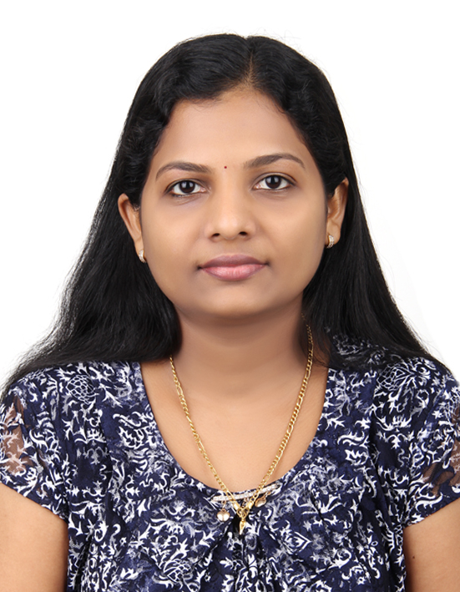
Dr.REEBA

Certified professional coder

Email: reeba.370318@2freemail.com

OBJECTIVE

Looking for a challenging position as a medical coder / IP and OP claims processor / Resubmission analyst / Authorization officer in health care industry where my technical. Logical & Analytical skills will greatly enhance the growth and success of the Insurance company / Hospital. A position to learn incessantly to contribute effectively, and to grow along with the organization.

PROFFESSIONAL QUALIFICATION
- Certified professional coder from AAPC-CPC
- MCB-medical coding and billing from Gulf medical university -ajman

Professional Synopsis
- Holding license in certified professional coder from AAPC(CPC-A) and degree in bachelors of homoeopathic medicine and surgery with 5 years of experience
- Expertise in handling a diverse range of basic level in medical coding , medical terminology, anatomy , physiology.
- Responsible for evaluating medical record documentation to ensure that diagnostic and procedural codes. Accurately reflected and support the medical necessities.
- Well versed ,ICD-10 CM,CPT,HCPCS level -2 codes, physicians desk reference.

EXPERTISE & SKILLS

- In depth knowledge of medical procedures and principles
- Deep knowledge of medical conditions and remedies
- Good clinical and therapeutic knowledge
- Ensures co-ordination and delivering of all works activities within area of responsibility
- Ensures client expectations are met and quality client service principles maintained and complaints solving property
- Screen medical reports , ensures complaints of medical requirements of individuals in standard of occupational health
- Provides excellent customer service to improve relationship with patients hence enhancing the business
- Outstanding ability to maintain the professional relationship with patients and employees
- Ability to maintain compliance to safety regulations
- Well-developed administrative and organizing skills
- Maintaining patients medical records in accordance with the hospital policy

Organizational experience

RIYAS MEDICAL CENTRE,ALSHAHBA,SHARJAH
Worked as a MEDICAL CODER:-
- Abstract clinical information for a variety of medical records
- Assigned appropriate ICD-10 and CPT codes to patient records
- Analyzed, entered and manipulated databases and confirmed appropriate DRG assignments

Hari and Hari Homoeopathic research centre,INDIA.
Since 20th aug 2012 to 13th sept 2014
Worked as a MEDICAL OFFICER:-
- Perform research in medical conditions and provide remedies
- Monitor patient progress and maintain records
- Perform preliminary examination of patients and diagnose the nature of the medical condition
- Fill up the medical chart by providing details of the vital medical statistics of the patient
- Accompany the team of medical practitioners during their visits to medical camps .
- Administer medicines to the patients under the guidance of the chief doctor
- Giving appropriate health education and advice to the patients and care takes to enable their self-management
- If necessary referring the patient to hospitals or specialist for further investigation.

Reeba homoeopathic centre , INDIA.
since 15th jun 2010 to 26th dec 2011
Worked as a MEDICAL OFFICER:-
- Monitor patient progress and maintain records
- Perform preliminary examination of patients and diagnose the nature of the medical condition
- Administer medicines to the patients under the guidance of the chief doctor
- Giving appropriate health education and advice to the patients and care takes to enable their self-management
- If necessary referring the patient to hospitals or specialist for further investigation.

vinayaka missions homoeopathic medical college, India since April 2009 to March 2010
Internship:-
- Case taking and diagnosing the medical conditions in outpatients and inpatients
- Attending the inpatients rounds for monitoring their disease status
- Fill up the medical records in inpatients and outpatients and writing the lab investigation and reports
- Prescribing the medicines under the guidance of chief doctor
- Attending the seminars and medical camps
- Presenting seminars and dissertation work

EDUCATIONAL QUALIFICATION

- Bachelor of Homeopathic Medicine & Surgery (BHMS)
Vinayaka Missions university - 2004 to 2010
Vinayaka Missions homoeopathic medical college , Salem, Tamilnadu .India

ACADEMIC QUALIFICATION

- Plus two with majors in PCBM
Kerala University - 1999 to 2001 St.Marys higher secondary school Edoor .

Computer knowledge
- Microsoft word, excel & power point presentation

TRAINING
- Basic life support course –healthcare providers course from university of sharjah clinical training centre, uae. course conducted on 7/2/2015.
- Personality development program –Has undergone personality enhancement and soft skills and communication training .
- Attended course of nutrition and dietary management program.

SEMINARS
- National Homoeopathic Seminar
Topic : Endless Potential of Homoeopathy
Venu : Vinayaka missions homoeopathic medical college , Salem,Tamilnadu .India

PERSONAL PROFILE
Name : Dr. Reeba
Date of Birth : 23-12-1983
Gender : Female
Marital Status : Married
Place of issue : Cochin
Date of Issue : 19-05-2011
Date of Expiry : 18-05-2021
Visa Status : Husband’s Sponsorship
Languages known : English, Hindi, Tamil & Malayalam
E-mail Address : reeba.370318@2freemail.com

DECLARATION
I consider myself familiar with medical aspects and I am confident of my ability to work in a team .I hereby declare that the information furnished above is true the best of my knowledge.

Date:- Yours sincerely
Place:- Dr. REEBA

