RESUME
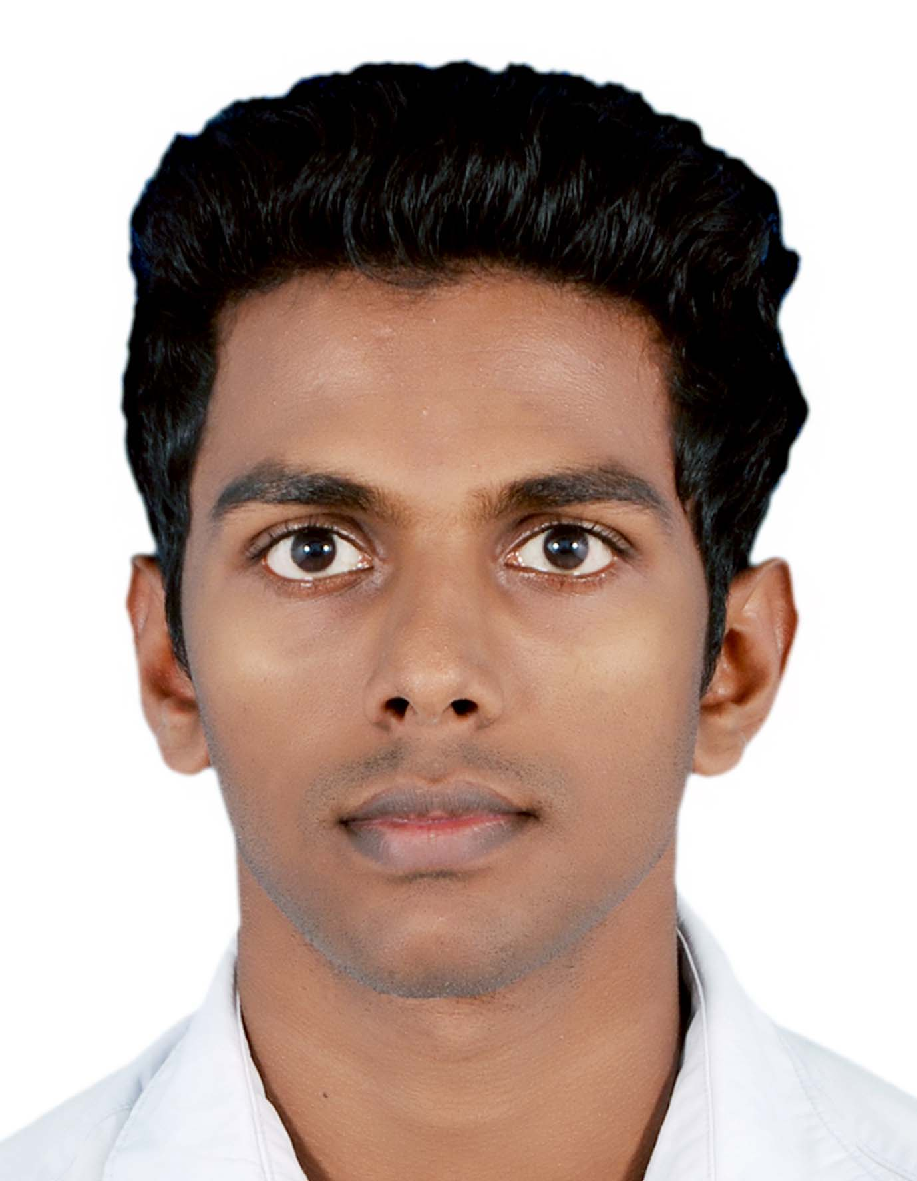
ANTO
Email: anto.370415@2freemail.com | Bachelor of Engineering  (Mechanical Engineering)  Maria College Of Engineering & Technology  (Affiliated to Anna University-Chennai)

Career Objective
A career with a progressive organization that will use my education, skills and abilities in an executive capacity, where I can effectively contribute to operations in any capacity that best matches my skills

Employment History

Organization : Vision Mission Success Polytech (VMS polytech)
Duration : June 2015 to Till date
Designation : Production Engineer

Summary: Responsible to ensure maximum production quantity and quality, while supporting the policies, goals and objectives of the company.
- Lead the specification, sourcing and ordering of components for equipment manufacture or refurbishment.
- Liaising with contractors to establish a rebuild or manufacturing policy to increase capacity and improve quality.
- Control sub-contract labour for electrical/mechanical projects to ensure timely budget delivery.
- Co-ordinating machine rebuilds in Precision production to increase capability and capacity.
- Manage and maintain databases in the Assembly.
- Check machine capability to ensure correct qualities of machine or product.
- Raise applications for capital expenditure for new machines and process improvements to improve efficiency.
Academic Profile

Bachelor Of Mechanical Engineering(B.E)-2015
- Maria College Of Engineering & Technology, Attoor
- Secured 66.8%
Higher Secondary Course(HSC)-2011
- St.Mary Goretty Higher Secondary School, Manalikarai
- Secured 68.9%
Standard 10 (SSLC)-2009
- St.Mary Goretty Higher Secondary School, Manalikarai
- Secured 85.4%

Computer Proficiency

- Auto CAD

- MS-Office

English Proficiency

Scored 6 bands in International English Language Testing System (IELTS) academic schedule on March 2017

Personal Details

Date of Birth : 09th May 1994
Gender : Male
Nationality : Indian
Languages : Tamil, Malayalam, English

Other Interest

Playing and watching Cricket
Reading Newspapers and Magazines
Software engaged file making

Declaration

I am a genuine personality. I am confident in my positives and very much aware of my negatives. Due to my intentional hard work, I could change by whole behavior to a hard working personality. I hereby declare that all the given information are true, complete and correct to the best of my knowledge and belief.

Thank You for your Time and consideration

Sincerely

ANTO

