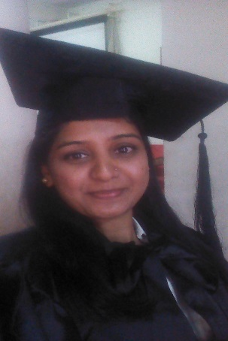

Name: BHARTI

Email ID: bharti.370517@2freemail.com

OBJECTIVE
My aim is to use the most of my potential and discover new horizons in the field of law. To secure a position in legal field and translate my theoretical knowledge into practical actions and enhance my legal knowledge and provide hands-on experience to take on bigger responsibilities in future roles.
I aspire to work with a company or a firm. I am committed to make the most of every opportunity to develop my legal skills.

AREAS OF INTEREST
- Paralegal services

- International law

- International trade

- Intellectual property rights.

- Human rights

EDUCATIONAL QUALIFICATIONS
Year 2016-2017 | Degree (L.L.M.)  International law | PERFOMANCE  (Marks in %)
January 2017  March 2017  May 2017 | Semester I  Semester II  Semester III | 76.67  72.61  Waiting for results

Year- 2013-2016 | Degree (L.L.B.)  SAVITRIBAI PHULE PUNE UNIVERISITY | PERFOMANCE
April 2016  October 2015  April 2015  October 2014  April 2014  October 2013 | Semester VI  Semester V  Semester IV  Semester III  Semester II  Semester I | Higher second class  Second class  Second class  Second class  Second class  Second class

year | DEGREE | UNIVERSITY | Performance
2014-2015 | Diploma in post graduation in business and corporate laws | Symbiosis education society Pune | First Class

Institution | Class | Year | Board | Performance
Bachelor of Arts | BA in ENGLISH | 2010-2013 | Pune university | 68%
SRVM HIGHSCHOOL Secondary School | XII Class | June, 2007 | Board of Secondary Education, Maharastra | 63.17%
SRVM School | X Class | May, 2005 | Maharastra divisional board | 66 %

WORK EXPERIENCE
- Law Office: Senior Advocate Rinku Agarwal (INDIA)
Position: Intern
Period: December 2015– February 2016
Prepared drafts and applications and typing
Court: Pune District Court
- Law spades Pvt Ltd, PUNE(Maharashtra) India
Position: legal executive
Period: July 2016- September - 2016
It is a LPO on US court law cases
ADDITIONAL QUALIFICATION
- Certificate in Marathi Typing – 30 Per Minute
- Certificate in English typing - 40 per minute

CO-CURRICULAR ACHIEVEMENTS
- Participated in STATE LEVEL ELOCUTION COMPETITION in subject the place of women in Indian society in 2007
- Participated in one day Bhartiy loknaylay as being panel member
- Participated in NATIONAL SEMINAR ON disaster management in Pune 2015
- Participated in Bhartiy Chatra sansad 2015 for interest in politics
- Participated in Kavi samellan, Jodhpur and pune. .
Seminars/ Workshops Attended
- Capsule Course on Cyber Law- Contemporary Issue
- Capsule Course on Intellectual Property Rights and Corporate
- Capsule Course on Mediation and Conciliation in PUNE
Personal Information

Name: Bharti

Gender: Female

Nationality: Indian

Marital Status: married (husband working in Etisalat)

Date of Birth: 01-01-1990

Languages Known: English, Hindi, Marathi and kannda

Email ID: bharti.370517@2freemail.com

I hereby certify that the information contained herein is true and correct to the best of my knowledge, information and belief.

