Mohamed
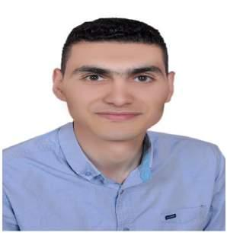
Personal | Nationality: Egyptian
Information
 | Birth date: 23 JULY 1991
 | Marital Status: Single
 | Address: Ajman, UAE
 | Residence : Transformable
 | Email: mohamed.370651@2freemail.com

Education

Bachelor's Degree in Physical Education, Alexandria University, Egypt in 2012. Master's Degree in Physical Education, Alexandria University, Egypt in 2016.
Experience

Former Physical Education Teacher at ALaqid Ali Almasri Primary School 2011/2012. Former Receptionist at Blue Wave Club, Gym and Spa 2014.

Former Assistant Soccer Coach of 16 years team at Disuq SC for a year 2015/2016. Private Soccer Coach since 2012.
Training Courses

Advanced Course in Sports Marketing from Alexandria University . Advanced Course in Sports Injuries from National Sports Council of Egypt . C, License in Soccer Coaching from Confederation African de Football .

Computer Literate

Language

Skills

Holds the ICDL.

Arabic as a mother language.

English as a foreign language.

Designing of Sport's Training programs. Planning of Sport's Training loads. Teaching of Motor Skills for kids. Teaching of Physical Education. Management of Sport's events.

