RESUME

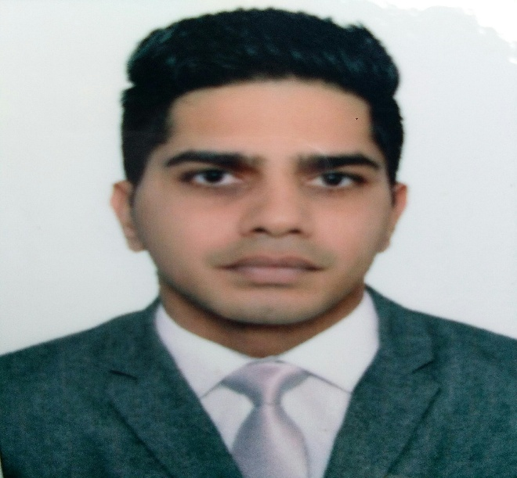
SUKHWINDER
Al satwa, Dubai.
Email:
Sukhwinder.370658@2freemail.com

Objectives

To work in informative environment where I can implement my skills and knowledge to the best of my ability. To pursue a career in an organization, that allows utilizing my creativity and conceptuality

Major qualification

- Excellent ability to communicate well with people from different cultural backgrounds
- Learn how to work well in a team & accept constructive criticism
- Highly self motivated, soft spoken, industrious and flexible
- Active, people oriented and can work under pressure
- Achieve basic reservation course in amadeus (airline ticketing)
- Achieve and attend six months training of fidelio (hotel operations management)

Work experiences

Banquet supervisor (June 2015 to may 2016)
Abu Dhabi national hotels
khalifa city , Abu dhabi
Duties and responsibilities
• Completes steps of service to ensure utmost guest satisfaction
• Understands and can describe menu offerings, packaging/presentation and pricing
• Responds to guest needs and requests
• Establishes rapport with guests/members
• Always exceeds guest expectations
• Maintains service areas
• Employs good safety and sanitation practices
• Adheres to Levy Restaurants Company guidelines as stated in team member training
manual and employee handbook
• Follows responsible alcohol service.
• Supervises all team members, non-profits and subcontractors assigned to the area for
the duration of the event

Service supervisor (May 2013 to may 2015)
Intercat hospitality LLC
Baniyas Abu dhabi,
Duties and responsibilities:
- The primary responsibility is to provide good food and quality service.
- Handling and solving the guest complaints.
- Communicate service needs to chefs and stewards throughout functions.
- Total charges for group functions, and prepare and present checks to group
- Ensure banquet rooms, restaurants, and coffee breaks are ready for service.
- Ensure proper centerpieces are displayed on every table.
- The cleanliness and presentation of all china, glass, and silver prior to use.
- Set tables according to type of event and service standards.
- Communicate additional meal requirements, allergies, dietary needs, and special
Request for kitchen.

Banquet supervisor (April 2011 to January 2013)
Duties and Responsibilities
Golden tulip ambient resorts and spa
Sector 1 panchkula india
Duties and responsibilities
- Supervise activities of workers in section of dining room .
- Receive guest and conducts them to tables
- Describes or suggests food courses and appropriate wines
- Resposible to close daily banquet billing according to procedure
- Responsible ensuring sufficent operating guest supplies, beverage supplies.
- Responsible for all sanitation, cleaniness of the work areas, ball rooms and storage rooms

IInternship. ( January 2009 to January 2010)
Goldkist beach resorts
East coast road Singapore
Duties and responsibilities
- Work at front desk
- Greets, register and assigns rooms to the guest.
- Makes and confirms reservation.
- Check in , check outs in timely and courteous manners.
- Works at cafe, handling daily cafe sales.
- Taking orders , serve orders to the guest.
- Suggest food to the guest.
- Works as housekeeping supervisor, issues supplies and equipment to workers
- Advises executive, desk clerk or admitting personel of rooms ready for occupancy.
- Establish standards and procedures for work of housekeeping staff .

Banquet Server ( May 2008 to August 2008 )
( J.W Marriot Hotel)
Orchard road singapore
Duties and Responsibilities

- Serve all the food courses and beverages to the table on time.
- Clearing the tables.
- Do the set ups for functions as required .
- Resposible for being proffesional and courteus to all the guests.

Education Attainments

- Matric -d.a.v senior secondary school (March2002)
- Diploma in tourism and hospitality management
- (Nanyang Institute of Management Singapore) (May 2008 to February 2010)

References:
Mr Jumadi :- Manager (F.O , fourseasons hotel)
Mr Rosley :- Manager (F&B four season hotel )
Mr siva :- Supervisour (F&B, Marriott hotel)

Personal Information

Full name : Sukhwinder singh.
Natinality : India.
Date of birth :
Pasport no : .
Relegion- : Sikh
Marital status : Single.
Permanent address :
: English, Hindi, Punjabi
Visa status : visit visa expires 29th July.

I do hereby that the above mentioned status is best of my knowledge. If you have any queries please do not hesitate to contact the references.

