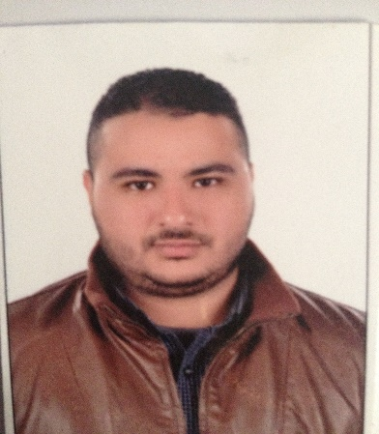
Mohamed
Email. Mohamed.370662@2freemail.com
UAE Driving License
Dubai, U.A.E

Objectives:

Look for a job in your organization where I can maximize communication skills and abilities
Skills, I have more than five years in customer service and remote sales and I have more than four
Years car driver

Education:

2000-2005 BSC Social Work

Languages:

Arabic: Mother Tongue
English: Good written and spoken

Personal Information:

Date of Birth: 24-04-1984
Marital Status: Married
Nationality: Egyptian
Visa: Employment Visa

Courses:

- Training Course Social Worker at Wafa and Al Amal Social Club (2005 - 2007)
- ICDL (MS Office)
- The Seven Habits of Highly Effective People
- Intensive course in the "FISH PHILOSOPHY"
- Customer Mania Plus
- Extended course in "HOW WE WORK TOGETHER"
- Extended Course in using "LAST" in handling a customer's complaint

Jan2013 – until Present: Call Center Agent Kuwait Food co. (Americana)

- Answer calls and respond to emails.
- handle customer inquiries both telephonically and by email.
- research required information using available resources.
- manage and resolve customer complaints.
- provide customers with product and service information.
- enter new customer information into system.
- update existing customer information.
- process orders, forms and applications.
- identify and escalate priority issues.
- route calls to appropriate resource.
- follow up customer calls where necessary.
- document all call information according to standard operating procedures.
- complete call logs.
- produce call reports.

Dec 2007 – Dec 2012: Delivery Driver Kuwait Food co. (Americana)

- Deliver a wide variety of items to different addresses and through different routes
- Follow routes and time schedule
- Load, unload, prepare, inspect and operate a delivery vehicle
- Ask for feedback on provided services and resolve client’s complaints
- Collect payments
- Inform customers about new products and services
- Complete logs and reports
- Follow Dot Regulations and safety standards

Sept 2004 – may2005 training of social worker in Social Insurance

Sept 2003 –MAY2004 training of social worker in el hood el mars oud hospital

Sept 2002 – May 2003 training of social worker in el wafaa and el A ml school

