Curriculum Vitae Stephy

PERSONAL INFORMATION Stephy
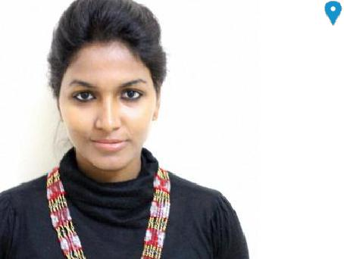

Stephy.370679@2freemail.com

VALID UAE DRIVING LICENCE

Date of Birth: 24/11/1992.

PROFESSIONAL APPOINTMENTS

September, 2016 To PRESENT Designer cum Buyer

Kashkha Plaza L.L.C,Dubai-U.A.E

Working as Fashion Designer cum Buyer for one of the top brands of UAE, Kashkha which have stores worldwide

- Trend Analysis & consulting (colour ,Fabrics, Trims, style )

- Create Design as per season, Trends & customer demands through softwares & also through sketches

- Sample Development

- Pattern making

- Getting the cut and sew done

- Getting the embroidery done & stone work done as per the design

- Sourcing (Fabric,Trim sourcing & consulting

- Attending Trade shows,Fashion weeks for trend analysis

- Buying (Analyse brand performance of previous season & rework on

upcoming season
- Reviewing the stock in the stores season wise

- Visiting stores regularly to understand customer demands o Selecting new products &reviewing the old
- Understand customer needs & design accordingly

- Reviewing the stock & replacing old with new designs as per the trends

  - season)
- Finding the right suppliers

- Maintain good relationship with clients while seeking for new ones.

- Helping to interpret reports and predicting future sales

Page 1 / 3

June, 2015 To July, 2016

Dec, 2014 To May, 2015

April, 2013 To July, 2013

EDUCATION

July 2011 To July, 2015

June 2008 To June, 2010

June 2007 To June, 2008

Curriculum Vitae Stephy

Designer cum Buyer

Worked as Fashion consultant cum Buyer with domestic and international brands such as Arizona, Okie-Dokie Xersion, Zara, and Mango among others.

- Trend Analysis & consulting (colour ,Fabrics, Trims, style )

- Create Design as per Buying calendar & seasonal Trends

- Product Development ( Season wise/category - Men’s, Women’s and Kids Apparels)

- Checking with fits & measurements

- Checking washes & experimenting with new washes ( for denim & various fabrics)
- Attending Fashion weeks for trend analysis

- Fabric,Trim sourcing & consulting

- Buying

- Ensuring the products are delivered on time

- Pitching ideas to senior management

- Reacting to any changes in customer demand & Getting feedback from customers

Intern - Vocational

Malhar Decor Private Limited, Mumbai, India.

Intern (Academic)

Kya Cheez Hai Design Studio, Bengaluru, India

"

Bachelor of Design- Fashion & Lifestyle Design

National Institute of Fashion Technology, Bhopal India

(Under Ministry of Textiles,Govt of India)

Higher Secondary Certificate Examination(HSC)

State Board of Kerala- English Medium

Secondary School Certificate Examination(SC)

State Board of Kerala- English Medium

Page 2 / 3

Languages Known

Skills

Computer Skills

Honours and awards

Projects

Co-Curricular

Achievements

Extra-Curricular

Achievements

Curriculum Vitae Stephy

English

Hindi

Malayalam

Tamil

Fashion Designing

Buying

Trend Analysis

Interactive Communication

Product Development

Software skills

Hand Rendering

0----------------------- 4-----------------------6------------------------10

MS-OFFICE (Word, Excel and PowerPoint), Corel Draw,Outlook, Autocad, Photoshop

- Awarded with the title "Miss Converge 2014" at the Converge 2014, a national level cultural festival organized by the National Institute of Fashion Technology, Bengaluru, India; 2013

- Awarded with Gold Medal for my excellent performance in Kerala State Math Contest; 2003

- Submitted a report on topic - "Competitive Analysis of Famous Footwear Brands", as a part of curriculum at NIFT, Bhopal. I have provided comparison between 2 internationally recognized footwear brands, Nike Inc. and Adidas AG. Included chapters in the reports are as follow as; Product Portfolio Analysis, Key Product Development, Financial Analysis with respect to Net Sales and Operating Cost, Business Strategies and Geographical Penetration; 2013

- Showcased product portfolio at “NIFT Spectrum - 2013”, a national level platform to present product portfolio under segment - Garments and Accessories

- Showcased product portfolio at “NIFT Spectrum - 2012”, a national level platform to present product portfolio under segment - Garments and Accessories

- Attended various workshops, presentation and Talk shows, organized by famous brands, organizations and institution

  - Attended terracotta workshop organized by the Nation Institute of Fashion Technology-2012

  - Attended workshop focus on apparels and lifestyle accessories, organized by the National Institute of Fashion Technology, Bhopal, India; 2012

Thanks for Your Time and Consideration!

Regards,

Miss. Stephy

E-mail: Stephy.370679@2freemail.com

Page 3 / 3

