SHELTON
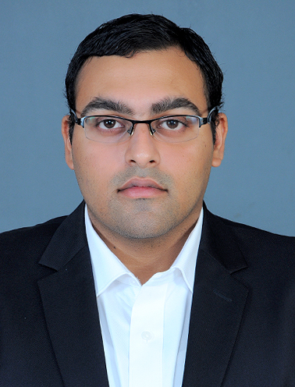

E-mail shelton.370690@2freemai.com Abu Shaghara, Sharjah, UAE

Personal Summary

Operations and Sales Management Professional, having experience in marketing of Security products and trading with leading brands like Scheidt & Bachmann, Came, Gunnebo, Jindal, Safex, etc. Having successfully coordinated the activities of various departments concerned with the supply, installation, maintenance, pricing, sales and distribution of products and services. Comfortable working with people of all levels and having an excellent commercial approach to solving problems and developing business processes. Having proven people management skills with the ability to manage performance and motivate staff on an individual and team level.

Core Competencies

- Marketing: Marketing strategies, marketing campaigns, customer focussed, sales oriented, brand awareness and presentation skills.

- Negotiating: Strong closing skills, Influencing skills, building relationships, account management, selling creatively.

- Dynamic: Increasing revenue growth, high energy levels, people management, business planning, writing reports.

- Smart: Coming up with ideas, Agile in cutting edge of technology, engineering and sales

SUMMARY OF QUALIFICATIONS

- Over 8 years of pre- and post-sales experience with several engineering products.
- Proven track record in all stages of sales process, from business development and lead qualification to Requests for Proposals (RFPs), technical needs analysis, and closing.
- Solid technical acumen with background writing white papers and sales strategies.
- Collaborate with Sales, Marketing, and back office to optimize promotion of products and services.
- Exceptional presenter with solid background in pitches & snap demonstrations.
- Superior analytical, communication, and interpersonal skills.

Experience Overview

Organization : DANAT ALAFAQI GENERAL TRADING L.L.C
Location : DUBAI – U.A.E
Designation : Business Development
Duration : April’ 2014 - Present

Company Profile:

An expertise in parking equipment technology and security products with well trained installers. Danat delivers effective parking management systems, consultancy, premier security solutions expert service support and maintenance.

Roles and Responsibilities:

- Provide pre- and post-sales services, including business analysis and bid support, to identify customer technical requirements relating to technical and commercial solutions.
- Liaise with the technical department for product submittals and necessary approvals.
- Arrange technical meetings with the consultants and provide presentations regarding our product range and get them listed in the tender document.
- Research on new brands and other related products depending on the customer requirement.
- Preparing and presenting potential cost benefit analysis to potential clients like Return of Investment (ROI).
- Expand the business within U.A.E and provide after sales support to the end user.
- Reviewing customer drawings, plans and other documents in order to prepare detailed technical proposal for them.
- Negotiating with manufacturers, for better margin of discounts for project based order placing.
- Follow up with payments.

Organization : IMPERIAL TRADING AND CONTRACTING COMPANY
Location : DOHA - QATAR
Designation : Sales Engineer / Division Head (Mechanical Trading)
Duration : Nov’ 2011 – March 2014

Company Profile:

A leading Grade ‘A’ MEP, Civil contracting and Trading Company in Qatar dealing with major Govt projects in Qatar.

Achievements:

Was given the responsibility to Head the Mechanical Trading Division, to handle the sales and marketing of GI sheets, GI coils, other Ducting accessories, Overhead cranes etc. after successfully completing just six months as Sales Engineer. I was given the opportunity to take the distribution & negotiate with Caryaire for the ducting accessories & Cranes of the renowned brand Safex. These products though existed in the market but were new to our company. In 2013 we have increased the overall sales by 70% in comparison to previous year figures.

Roles and Responsibilities:
- Reach out for prospective clients; achieve sales target and forecasts in every month.
- To order and maintain adequate stock in order to service our cliental.
- Order placing to the manufacturer, co-ordinate with the accounts department for the opening of LC, petty cash etc.
- Negotiating with suppliers / manufacturers, for better margin of discounts for project based order placing.
- Organizing conferences, making product presentations and submittals to consultants MEP& HVAC contractors for product awareness and approval.
- Organizing sales campaign and promotions for creating customer interface.
- Preparing yearly budgetary plans by close consultation with the finance department, thereby implementing cost control techniques.

Organization : CALYX SOFTWARE SOLUTION
Location : India
Designation : Senior Marketing Executive
Duration : June’ 2008– Sept 2011

Roles and Responsibilities:

- Meet the monthly target as proposed by the Organization.
- Meet the Client and provide presentations regarding our product.
- Conduct Routine customer visits & build strong relationships.
- Organize the monthly sales meeting.
- Expand the sales within the territory.

Educational Background

MBA in International Marketing from Indian School of Management & studies.

Bachelor of Engineering(Mechanical) from Hindusthan College of Engineering & Technology, Anna University – Chennai, India.

Additional Courses

Diploma in AutoCAD, Catia & Pro-E from Cadd Centre, Coimbatore, India.

Primavera from CADD Centre, Coimbatore, India

Computer Skills

- MS – Office, 2) MS – Outlook , 3) MS – Word, 4) MS – Excel
5) Power Point Presentation.

Personal Vitae

Date of Birth : 08th February 1987
Nationality : Indian.
Status : Married.
Languages : English, Hindi, Malayalam, Tamil
Driving License : Yes
Notice Period : 30 days.

Declaration
The points above are just a brief of my experiences in my career until today. More information’s regarding the subject and degree certificates to be provided, once we are in serious discussion.

Place: Dubai, UAE Shelton

