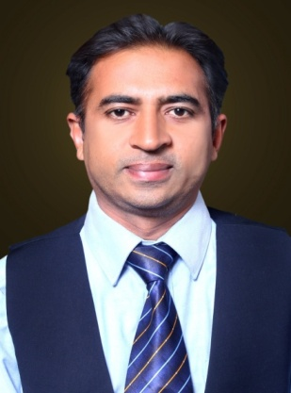
Shahzad

Shahzad.370720@2freemail.com

I have two years visa of UAE (2017-2019).

Professional Summary
A highly motivated and detail oriented professional with more than ten years of successful career in teaching, honored by Diploma TEFL, ACCA(1) and Masters in Commerce. I have much to offer in terms of teaching Accounting and Business with strong interpersonal and analytical skills topped up with the knowledge of my field. Presently looking a challenging role in forward-looking organization to use gained knowledge and skill. Ready to assume responsibilities with vigor and commitment. Also having a good experience of management.

Core Competencies:

- Strong skill of judgment
- Good Communication skill
- Team player with strong leadership ability

- Visionary approach towards issue resolution
- Great Performance

Experience

Organization: Concordia College Faisalabad. (A Project of Beaconhouse School system)
Designation: HOD( Commerce) & Head of Examination Cell.
Tenure: 2015- to 2017.

Major Responsibilities
- Teach first & second year business and Accounting students.
- Give and select topics for open discussion.
- Assess the Business & Accounting abilities of students by different activities.
- Discussion with junior staff on the progress of students and syllabus coverage.
- Conduct weekly or monthly staff meeting.
- .Team leader of Examination Cell.
- Arrangements for a safe conduct of in-house examination
- Facilitation of teaching staff in preparing exam papers, printing of papers etc.
- Supervision of results making, by class incharges.

Organization: Faisalabad College of Science
Designation: Lecturer in Business studies and Economics.
Tenure: 2010-2015

Major Responsibilities:
- Teach first & second year Business and Economics students.
- Prepare lesson plans for different activities.
- Amend the lesson plans and activities accordingly.
- Give and select topics for open discussion.
- Keep the students engage in classroom by using different techniques.
- Give and mark the homework regularly.
- Assess the Business abilities of students and make progress report.
- Discussion with colleagues on the progress of students.
- Attend weekly or monthly staff meeting.

Organization: Government College samanabad, Faisalabad.
Designation: Lecturer in Commerce (Business and Accounting)
Tenure: 2007-2010

Major Responsibilities:
- Teach Accounting and Business to first year college students.
- Prepare lesson plans for the class.
- Prepare activities for Business and Accounting.
- Give and select topics for open discussion.
- Keep the students engage in classroom.
- Arrangement of tour for Business activity.
- Group discussion by giving topic on Business.

Organization: Lahore Grammar School, Faisalabad
Designation: Teacher O level (Accounting & Business Studies)
Tenure: 2002-2007

Major Responsibilities:
- Teach Accounting & Business Studies to O level students
- Prepare lesson plans.
- Prepare activities and material for activities.
- Open discussion.
- Encourage the students how to speak on stage.(Presentation)
- Attend school meetings to develop the program.

Organization: The Educators High School, Faisalabad.
Designation: Teacher History and Pakistan Studies.
Tenure: 1998-2002

Education

- Diploma TEFL A.I.O.U- Pakistan. 2012 (Teaching English As A Foreign Language)

- Bachelor in Education University Of Sargodha, Pakistan. 2011

- Masters in Commerce B.Z .U-Multan, Pakistan. 2010

- Bachelor in Commerce University of the Punjab-Lahore, Pakistan. 1998

- ACCA Part-1 ACCA, U.K. 2004

- Certificate in English (6 months) National Uni. Of Modern Languages, Pakistan. 2011

Computer Skills

- Operating software DOS, Windows 7

- MS-Office. (Word, Excel)

- Oracle Financial ERP.

Personal Information

- Nationality Pakistani.
- Marital Status Married.
- Religion Islam.
- Languages English, Urdu, Punjabi.

