Circum Vitae

P e r s o n a l d a t a

Mirghani
Information Technology

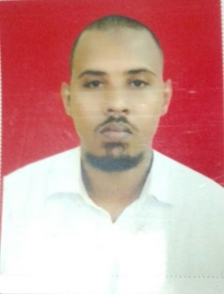

Date and place of birth : Kuwait 21/7/1986.

E-mail :
Mirghani.370888@2freemail.com

G r a d e s

Primary school : Almaghdad Ibn Amro , Shambat .

Date and place of birth :
Hassan Abd Algadir, Shambat.

University :

Courses:

Bachelor honor Computer Science and Information Technology from
Open University of Sudan .

Diploma in computer maintenance from Alimam Alhadi College .

a course in networking in Aldanga Institute. Cause in CCNA in network +

P a g e | 2

W O R K E X P E R I E N C E

National Service
2007
working in the coordinator of data base department for 10 Month .

Source information technology
2010 – 2012
Working in the Source information technology In networks and maintenance of computer sales for 2 years.

Brilliant Solutions
2013
Working in the Brilliant Solutions Company L.T.D had a training of Telecom and
Network Technician for 2 Months .

Customer Service
Center
2013 – 2014
I spent a period training company Sudanese Electricity Distribution Co Ltd . manages the distribution of power in Khartoum and in the field of customer services center in the period.

E D U C A T I O N

Open University of  Sudan  2012 – 2015 | Bachelor honor Computer Sciences and Information Technology .
Alimam Alhadi College  2003 – 2006 | Diploma in computer maintenance .

S K I L L S

Technical Proficiency in the use of computer and some software .
ability to communicate with different styles of people skills . Sales skills and dealing with customers .
Work under pressure and accept the opinions of others .

Languages Proficiency in speaking and writing my native language "Arab" Proficiency communicate in "English"

