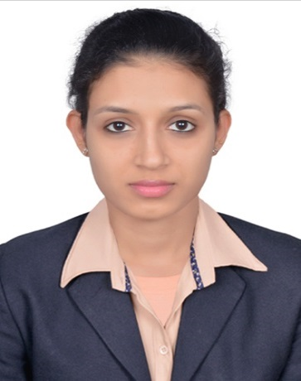  joslien  Joslien.371277@2freemail.com  - PLACE OF ISSUE: Bangalore.  Personal skills:  Good verbal and written communication skills, willingness to learn, team facilitator, a good listener and a hard worker. | OBJECTIVE:  To join an established, progressive and professionally managed organization this will provide adequate opportunity and environment to draw upon my knowledge, experience and clear strength to mutual benefits of the organization and myself.  ACADEMIC RECORD:  Diploma in Computer Science- DTE KARNATAKA  Period : 2011–2014  1st SEM Nov-11 53.48%  2nd SEM May-12 58.74%  3rd SEM Nov-12 55.77%  4th SEM May-13 55.54%  5th SEM Nov-13 61.93%  6th SEM May-14 69.33%  Institute : N.R.A.M. Polytechnic Nitte  S.S.L.C (10th Standard) – State Board of Karnataka  Period : March 2009 (68.8%)  School : Holy Rosary HighSchool Moodbidri  WORKED EXPERIENCE:(1 year)  NAME OF CONCERN : AEGIS pvt.lmt  - ForFlipkart(catalog helpdesk)process.  DESIGNATION:Senior Executive in operations  PERIOD: May 2016 to May 2017  Work Profile:  - Solving OTRS and FA,Misshippment tickets.  - QC passing  - Handled project of Compatible devices for Mobile Cases and Covers.  PLACE OF WORK : Bangalore(INDIA)
Personal Profile:  Father’s NAME : Francis D’mello  MOTHER’S NAME :Eveline D’mello  AGE : 23Years  Gender :Female  Nationality :Indian  RELIGION : Christian  MARITAL STATUS : Single  LANGUAGE KNOWN:Hindi, English, Kannada, Tulu,Konkani.  Interests:  - Computer Networks  - Internet  HOBBIES:  - Playing Chess  - Carom  - Badminton  - Listening Music & Singing  Positive traits:  - Eager to learn new things  - Self-Motivated | WORKED EXPERIENCE:(1 year 3 months)  NAME OF CONCERN : THE SOLITAIRE HOTEL  DESIGNATION : Hostess  PEROID : October 2014 to JAN 2016  PLACE OF WORK : Bangalore.INDIA  WORKED EXPERIENCE:(3 months)  NAME OF CONCERN :HOTEL CORAL TREE  DESIGNATION: Hostess  PERIOD : June 2014 to October 2014  PLACE OF WORK :R.T Nagar Bangalore. INDIA  Technical skills:  C, C++, VB.net, Photoshop & Macromedia Flash, JAVA, Java Script, HTML, XHTML, My SQL, Hardware Networking etc.  Rewards and Recognisation:  Rewarded for the excellent performance shown during Flipkart Big Billion Day Sale.  I Hereby Assure that the above information is true and I will prove to be worthy of your confidence and satisfaction.  Place :  DATE : JOSLIEN

