CURRICULUM VITAE  Ms ROSHINI  ROSHINI.371372@2freemail.com  Personal Data:  D.O.B: 06th jun 1997  Sex: Female  Nationality: Indian  Marital Status: single  Languages Known:  English,Hindi,Marathi  Interests  Reading Books,  Watching Games. | 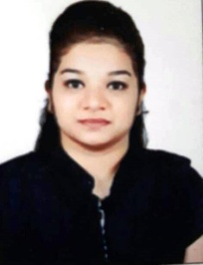  Career Objective  To secure a rewarding and challenging position which will utilize my skills, ability and experience with progressive, growth oriented organization allowing for both personal and professional growth.  Professional Qualification  Currently Working on A Travel Agency As a coordinator in Dubai UAE  Academic Records  10TH PASSED C.B.S.E (Mumbai) 2013  Computer Proficience  I am Comfortable with the following application packages:  - Internet  - MS Office  - DTP  Strength  - Positive Thinking  - Responsible  - Smart Working  - Co-Operative  - Discipline  Declaration  I confirm that the information provided by me is true to the best of my knowledge and belief.

