

**CURRICULUM VITAE**

**Ernest**

[**Ernest.371493@2freemail.com**](mailto:Ernest.371493@2freemail.com)

**PERSONAL DETAILS**

Nationality : Ghana Civil Status : Single

Date of Birth : 05/12/1985 Languages Known : English

Sex : Male

Religion : Christian Visa Status : Residence (Dubai)

**OBJECTIVE**

To seek an executive position in a dynamic and visionary organization, and to efficiently progress further in the same field. My aim is to assimilate in the organization as such, so as to become a credible asset for the organization’s effective functioning, and be a proficient team player for the achievement of its aims and objectives.

**KEY SKILLS AND COMPETENCIES**  
  
**Professional**

* International Hotel Security experiences in access systems, investigative procedures, incident report writing and customer service.
* More than 6 years of experiences in Security Department as a professional Supervisor in the Middle East.
* Excellent motivational, interpersonal, presentation and trainer skills.
* Knowledgeable about Fire system & Fire fighting.

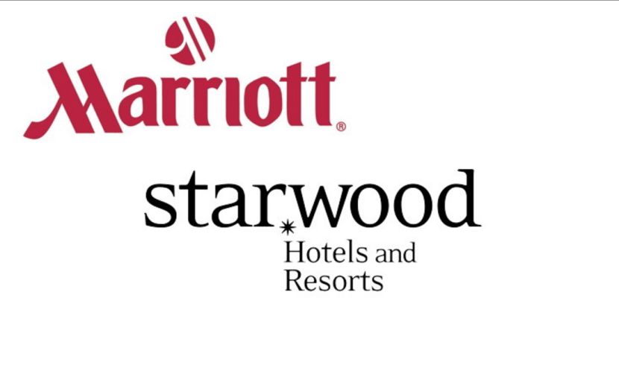**WORK EXPERIENCE**

**Head of Security**

**Dubai, United Arab Emirates**

**Sept, 2013 – Present**



**Duties Responsibilities:**

* Report and manage incidents, accidents, loss and / or damage to person and property within the premises. Investigate irregularities and enforce Hotel’s Loss Prevention Policy.
* Conduct inspection works, to identify maintenance needs of the premises or buildings.
* Provides assistance to the security guard on duty and prepare worked program schedule.
* Periodically inspect each officer location to ascertain that Security Officers are attentive and active to their job.
* Conduct On-Job-Training of new hires and executing orientation of all areas.
* Active Member of the Hotel’s Safety and Security Committee and in charge of preparing Meeting minutes
* Efficiently trained in problems handling, crisis intervention and tactical communications
* Perform under direct management of Security Manager to report daily activities and irregularities, such as equipment or property damages, theft, presence of unauthorized persons, or unusual occurrences
* Work closely with the Security Manager to achieve the best Safety standards to ensure the comfort and well-being of the guest and Hotel associates.

**Security Officer Dubai, United Arab Emirates**

 *Certis Guarding Services Company**March2012- August 2013*



**Place of Duty**: *Four Points by Sheraton Hotel*

*Downtown Dubai, UAE*

**Duties/Responsibilities:**

* Job includes checking specialization on the entire premises as well as ensuring the safety of the place against espionage, theft, and other danger.
* Monitoring more than 180 CCTV Cameras in the security Control room, controlling keys and master cards.
* Writing Reports in the log book for security Manager & Management on daily basis
* Making of Daily Patrolling and report all defects to Engineering Department and Management for maintenance
* Fully conversant with the Emergency Plan of Action
* Regular inventory of all keys/ key cards, loss prevention procedures in place, regular alarm testing of Fire system, general cashier office, elevators etc.
* Proper control with entry pass of Visitors/Contracts, Vendors and suppliers and regular check while leaving the premises

**CERIFICATES AND AWARDS**

* International Center for Security & Safety- **Security Manager** **(**City & Guilds London & Dubai Police Academy**)- *18th May 2017***
* International Center for Security & Safety –**Security Supervisor** **(**City & Guilds London & Dubai Police Academy**)- *25th June 2014***
* International Center for Security & Safety –**Security Guard** **(**City & Guilds London & Dubai Police Academy**)- *15th March 2012***
* Supervisor License from Dubai Police General H.Q **(**BY SIRA**)**
* Safety & Fire Training Certificate **(** BY SAFER fire Safety Consultancy**)**
* CPR, AED and Basic First Aid Certificate **(**BY American Safety & Health Institutes**)**
* HABC LEVEL 2 International Award in Emergency First Aid at Work
* Security Officer Certification Program **(** BY Global Security University International Tier 1-4**)**

**ACHIEVEMENTS**

* Supervisory Skills Certificate **(** BY Four Points by Sheraton Downtown, Dubai **)**
* Certificate of Recognition **(** BY Four Points by Sheraton as Brand Champion Leader of 1st Quarter**) *January, February & March 2015***
* Certificate of Recognition **(** BY Four Points by Sheraton as the Leader of the year 2015)
* Departmental Trainer Certificate
* Safety Seminar, Food Briefing & Legionella Lecture Certificate- Starwood Hotels & Resorts
* Diploma in Workplace Safety & Health **(** BY Alison Advance Learning Interactive Systems **)**

**ACADEMIC QUALIFICATION (ATTESTED)**

**INSTITUTE OF TROPICAL AGRICULTURE & MINISTRY OF FOOD & AGRICULTURE (GHANA)**

*Diploma in Crop Science with Second Class (Upper) October, 2009*

**ADDITIONAL SKILLS AND CAPABILITIES**

* Excellent communication skills, written and verbal
* Strong leader with a passion for maintaining high standards in service to ensure guest satisfaction
* Advanced technical skills in all Microsoft Office Program, Marriott Global Source, Opera. ETC

***I certify that all above information are true to the best of my knowledge and believe***. ***References will be furnished if desired***