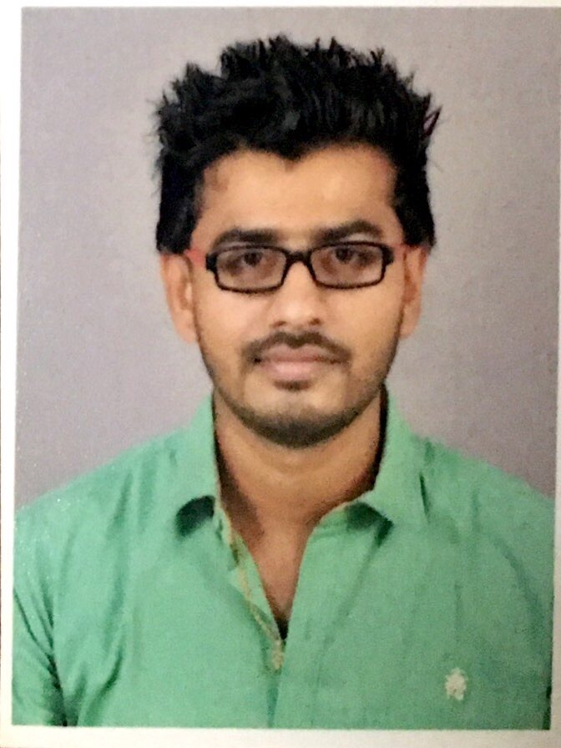
JEETHESH
JEETHESH.371821@2freemail.com

Objective

A motivated, results-focused professional, over 3 years of experience in Marketing, Operation Management, Event Management, administrative duties and seeking an opportunity to utilize skills, and education to contribute to employer objectives, profitability, and success with a company offering potential for challenge and growth.

Core Competencies

Business Development Operations Management Negotiation Employee communication Event Management Administration
Client Relationship Team Building Training & Development Risk Management Employee engagement Database Management
Vendor Management Marketing Strategies Confidential Recordkeeping

Professional Experience

- Madhuban Graphics, Mangalore
Designation – Marketing Executive/Operations Supervisor
Duration – January 2014 – Till Date

Key Responsibilities-
- Responsible for handling the entire spectrum of printing and advertising activities.
- Identified ways to increase sales of client products and services.
- Worked with clients to determine realistic marketing budgets.
- Managed customer relations efforts for each client.
- Developed and implemented strategic marketing plans and tracked results.
- Maintained close client communications while clearly defining marketing objectives.
- Provided support to the marketing manager and other key team players.
- Devised effective ways to increase client sales.
- Responded to client inquiries.
- Calling up customers and advising them of new promotions that the company has.
• Delivering new proposals and pitches to a wide range of clients.
• Reporting on the effectiveness of various marketing campaigns
• Developing great client relationships that foster long term partnership and success.
• Establishing specific marketing briefs with clients from different sectors.
• Meeting with potential clients face to face to promote the company’s services.

- FROLIX – the fun run.
Designation: Event Manager/Managing Partner
Duration: May 2011-till date

Key Responsibilities- Event Manager

- Responsible for revenue generation and also encouraging repeat business.
- Working closely with exhibition organizers, stand designers and contractors.
- Developing, implementing and managing events.
- Organizing trade fairs, conferences, away days, product launches.
- Managing all group rooms and banqueting processes and procedures.
- Liaising with clients at a high level.
- Overseeing procurement of catering, audiovisual, security & rental needs.
- Managing relationships with sponsors.
- Preparing delegate packs and promotional material.
- Maintaining a calendar of events for effective long term planning & management.
- Supervising & coordinate the activities of personnel, subcontractors & vendors.
- In charge of accommodation, schedules, travel, day plans and registration procedures.
- Conducted research to identify new opportunities for bringing about innovation in events.
- Discussed specific requirements and expectations concerning the event with clients.
- Managed and developed a strategic plan of action to ensure that the cost of the event remains under the pre-determined budget.
- Searched and negotiated suitable venues or locations as per the requirement and budgetary constraints of client.
- Carried out all the functions as per legal guidelines and regulations.
- Worked on determining a suitable layout and theme for the event as per client’s specifications.
- Facilitated communication with professionals, including venue management, stand designers, caterers, contractors and equipment rentals to ensure efficient running of an event.
- Trained new and existing staff prior to the event so that all operations and duties were executed smoothly and as per clients’ guidelines.

Educational Qualifications

 | Board/University | Yr. of Passing | Percentage
MBA(HR & marketing) | KSOU | 2014 | 70%
B.B.M | Mangalore University | 2011 | 56%
HSC | Mangalore University | 2008 | 73%
SSC | Mangalore University | 2006 | 68%

ITSkills

- Completed Computer Basic Course from NIIT Institute, Mangalore.
- Excellent MS- office operation skills for all MS Office Application
- Internet Usage skills

Professional and other achievements

- Appreciated for consistently achieving targets and recognized by clients for customer service satisfaction.
- Elected as the NSS Secretary of the college (in BBM 2ndyr.)
- Captain of cricket team in college.
- Event Organizer/ coordinator for inter-college events.
- Conducted several intercollegiate fests in college.
- Took part in state level Cultural competitions held at Mysore, Bidar, Bellary (in BBM) and won awards.
- As an extracurricular activity, dancing being my primary hobby, took part in several dance competitions, dance shows and I choreograph Dance, Mime Shows, Dramas, Mad ads too.

I hereby confirm that the information provided above is true to the best of my knowledge.

